**Software Engineering CSIS 3275 -002**

**Group 3 Project**

**Members:**

**Tabitha Maru 300291152**

**Ozan Cin 300320226**

**Pengcheng Jia 300317033**

**Endru Suphato Sendiko 300335685**

**Summer 2021.**

ASPIRECRYPTO

INTRODUCTION

Aspire crypto is a company meant to make it easy for someone looking to learn about cryptocurrency investing, the user can invest as they would if they had money and trade with our simulated currency.

THE BUSINESS CASE OR PROBLEM STATEMENT

Existing companies with simulations are difficult to use because of the way how complex the data is displayed. The user also gets to choose the amount they can invest in, this will cover most types of people( whales who invest $1m as well as students or low income people who invest $10).

Our company will display data in readable ways as well as use statistics from the past to predict future prices. Usually there is information fatigue when companies display all the coins, this slows down the system as well as affects the usability of the app. However our app will limit the coins to 100(other companies limit to 2 or 10 coins which is too thin a scope for investors, their system is fast and easy to use though, but the customer has to seek other companies to have a diversified portfolio). For predictability, we will be able to do it short term so the user can make a more informed decision but is not bound to be a reality. Displaying the data as initial investment as well current price helps with risk management and to gauge how much they lost or gained making it easier to track investments. Unlike the usual way of just displaying current prices and a percentage PNL which is hard to use and make quick decisions required for trading.

THE SOFTWARE ENGINEERING PARADIGM

WaterFall model. Requirement, design, implementation, verification, maintanance.

This is an easier way for us as we are a small group and have little time to complete it. It is also a paradigm we all understand.

REVENUE MODEL

1. We intend to get revenue from charging no transaction fees, but we will charge the user 3% in price difference. This is a good option because the user is not charged lots of different fees which add up in the long run. Most of our competitors charge transaction fees and transfer fees as well.
2. We will also use ads on our web app which will be another source of revenue.
3. The user will pay a monthly fee to use our prediction feature.

REQUIREMENTS

*FUNCTIONAL REQUIREMENTS*

1. User registration and login

If the user wants to start learning to invest with the fake currency we provide, they have to login so they can access their investments, and their gain/loss. If they only wanted to view the market or familiarise themselves with our web app they do not need to login.

1. Wallet

This is where the user's portfolio and investments exist. The user chooses the coins to invest in.

We have our own stable coin(USDA) just like BUSD for Binance and usdc for coinbase.

that has a ratio of 1:1 to USD. (USDT was not used as it is not backed by the US government as claimed and has a lot of controversy).

The user can look at their investments directly as USD with price differences instead of the percentages that other companies use.

1. Transaction

The user can buy and sell cryptocurrency after selecting the fiat simulation money they wish to invest.

The user is then able to add more currency, withdraw the currency as well as trade the crypto( for example you can trade ethereum for cardano or waves for solana)

1. Price prediction

The cryptocurrency market is extremely volatile, but with statistics we can be able to predict the price in the short term. We will use candlesticks, graphs, past prices, past behaviours and social media data.

Due to world economics, environmental concerns, popularity, use cases and other factors we will not be able to predict the prices long term.

*NON-FUNCTIONAL REQUIREMENTS*

1. Efficiency

The market will only contain top 100 coins, to reduce user fatigue in terms of decision making. This is a good number as too little of a scope will limit the user but too much will overload the user.

1. Usability

The data will be displayed in such a way that it is easy to use. This is our main goal as a company, making a simulator that is easy for seniors, non technical as well as the average person. The headers will have description and the price will be displayed as a number instead of candlesticks which most non-finance people find it hard to read.

1. Performance

APIs will be used to display prices in real time, as well as a limited number of coins will be used. This will increase the performance of the web app. Also limiting the number of web pages as well as displaying data in an easy way without overloading the webpage will drastically improve performance.

USE CASES DIAGRAMS



DESIGN

a) Design Goals:

In the process of going from the analysis model to building the system design, design goals must be identified. These will specify qualities that the system must focus on, so that design decisions can be based on a specific set of criteria. Some design goals will come right from the non-functional requirements. Others must be elicited from the client.

Some Criteria for Design Goals

* Performance Criteria: Response time. Accurate data. Data prediction.
* Dependability Criteria
  + Robustness – the ability of the web app cope with invalid user input.
  + Reliability -- difference between specified and observed behavior.
  + Availability -- percentage of time the web app can be used to accomplish normal user tasks.
  + Fault tolerance -- Retrieve server cache when the API stops responding
* Maintenance criteria
  + Extensibility -- It is convenient to expand back-end functions by using firebase services, such as adding more login methods, adding email verification, adding cloud functions, etc.
  + Adaptability -- Firebase hosting can deploy websites for different front-ends,
  + Portability -- Firebase hosting can share back-end data with IOS and Android. This allows the site to be directly ported to mobile devices
* End-user criteria
  + Utility -- This program uses data visualization to make virtual asset transactions possible. Users can traverse more than 200 cryptocurrencies and have an intuitive price map and related forecasts for investment reference.
  + Usability -- The website has an intuitive user case process. Users can complete a series of operations such as registration/login, viewing asset lists, selecting asset transactions, viewing transaction history, and logging out according to the guide. You can also jump to the webpage through the navigation bar at the top.

b) The architecture of the system: We use Google Firebase to host our website. Firebase includes a series of integrated back-end services. Cloud function allows the back-end to obtain currency data through a third-party API and store it in the Firebase database. The front-end user accesses the content of the website hosted by Firebase hosting and retrieves real-time data. Users who log in under Firebase authetication can also view and store transaction data in the Firebase firestore database. Your data is safe in firebase, and you can also delete your account at any time. You can visit douglasproject.firebaseapp.com to see the prototype of our published website.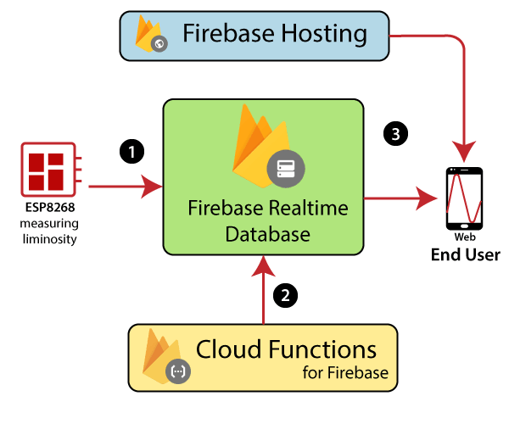

the final project is changed to XAMPP + SQLite3 architecture:

HOSTING:

 + 

CODING:

 

GRAPHING:

+  + 

TESTING:



c) The hardware and software configuration of the system.

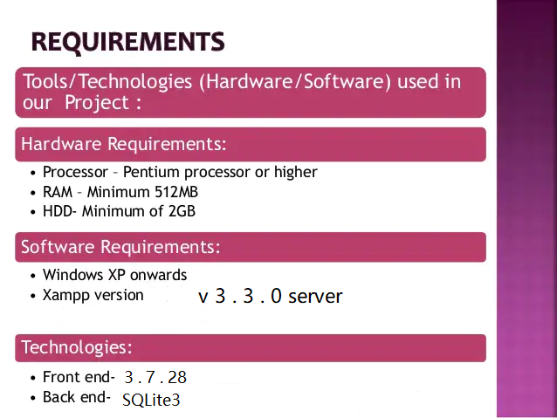

d) The database design

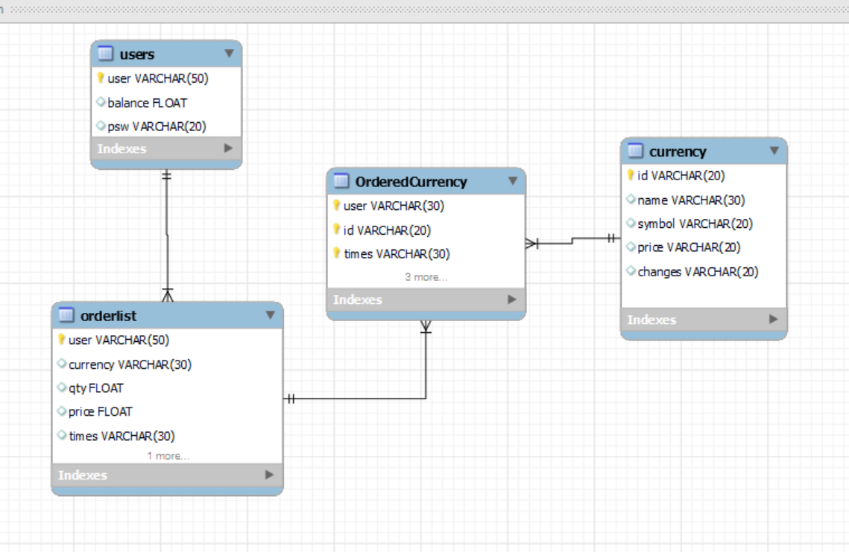

The SQLite3 database we use relational data structure. We will translate it into the following SQL schema.

1：The username after the user logs in is stored as the user (PK) in the users table

2: The user table has default balance of 0.00 usd

3: The user password are stored by md5 encrypted as hash values only

4: The currency we got from API is parsed into currency table, with ID as PK

5: If user made any purchase it will be stored in the order list table

6: we will have to join orderlist table with currency table to form an week type table which contains user, time from orderlist and id from currency as PKs use this table you can get all information needed to trace user transections

Change management:

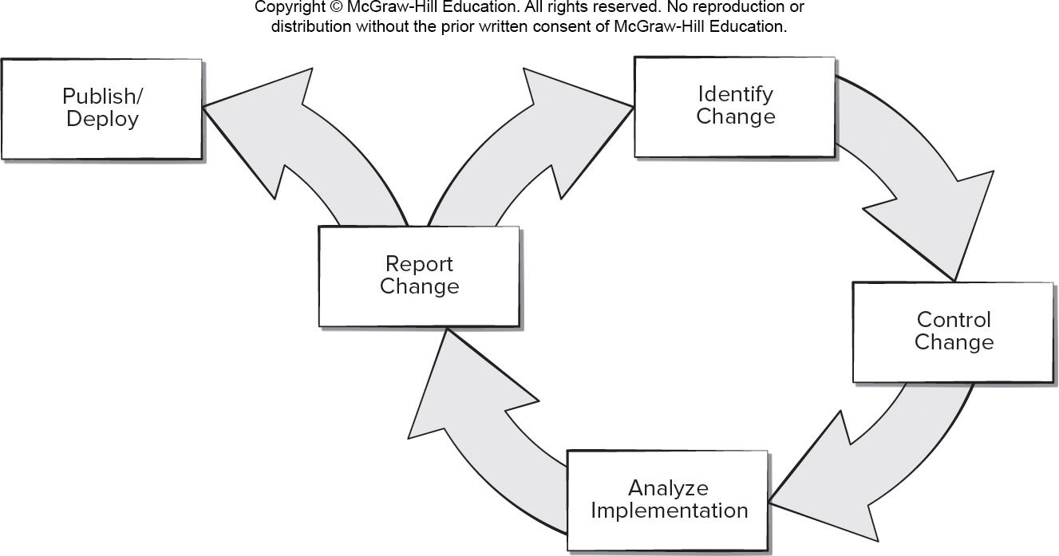

As we proceed on developing the project, we decided to migrate our project to a XAMPP based PHP Project for it to be more portable and usable outside firebase environment.

1: Identify change :

We notice that the user requirement are changed, As Tabitha required we need to migrate our prototype project from Firebase environment into XAMPP environment to improve adaptability.

2: Control Change:

Rather then Firebase, the XAMPP can support none static scripts so we decided to use PHP as our main language.

We need to use other way to manage user login ( not using firebase auth anymore)

We have to cut off the AdSence advertising due to we are deploy it in localhost

3: Analyze Implementation :

We decided to use SQLite 3 instead of MySQL in XAMPP. This is to make our app have less outside dependency, in case the MySQL service is port blocked by other hosting apps such as Tomcat and Wamp

We decided to use PHP_GD graphic tools to help with verification image generating, so that we can apply more security login process.

We decided to use Apache Echarts to generate price sparklines, instead of using D3+ SVG, because the Echart can have user interaction more easily

4: Report change:

We reported change after finished our final product, we shared changes made with group members before publish.

5: Publish/deploy

We have set up new baselines and have new version control archived. We tried to publish the new app in GitHub and blackbox tested it.

e) The Interface design

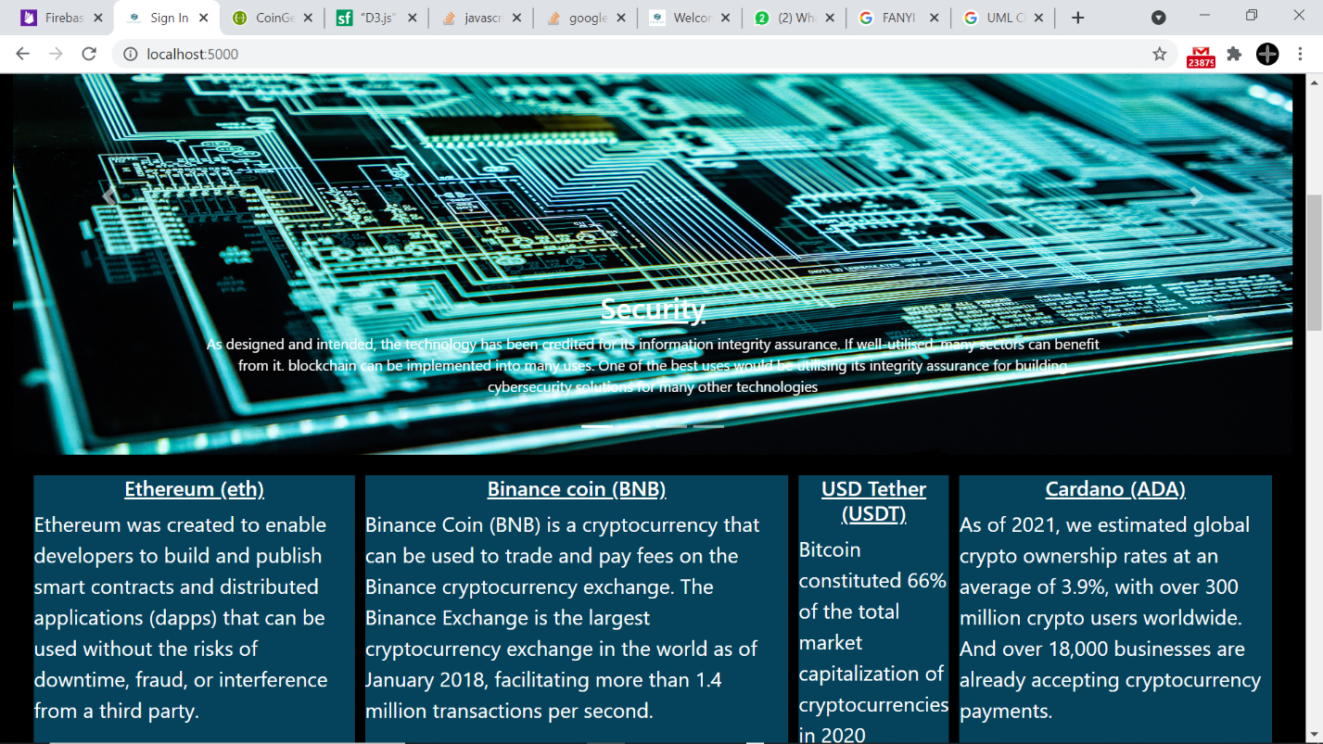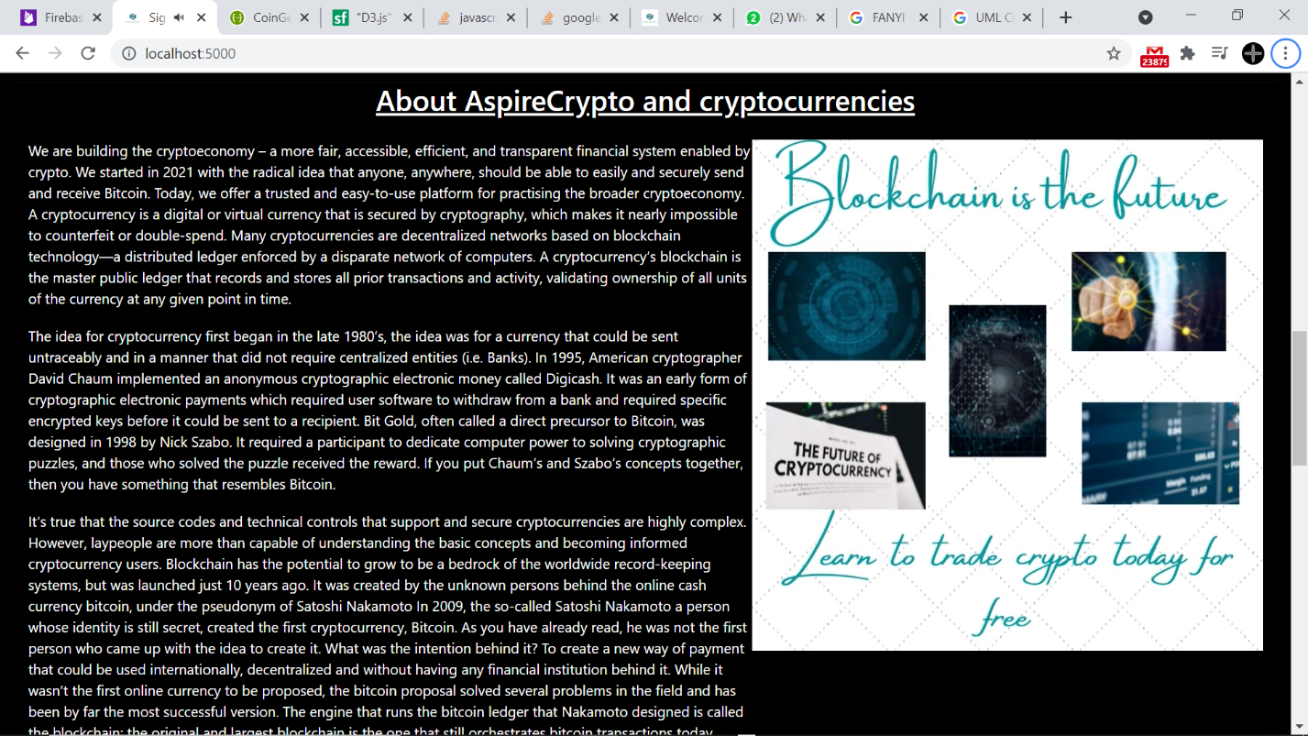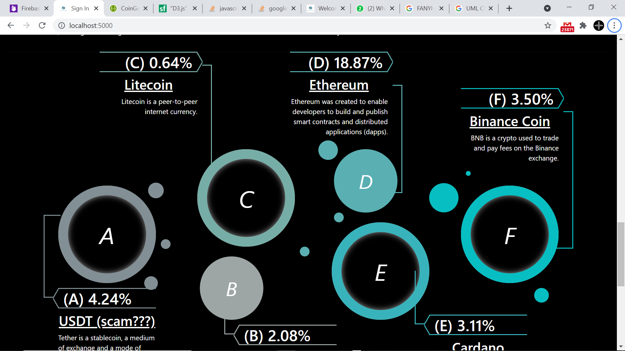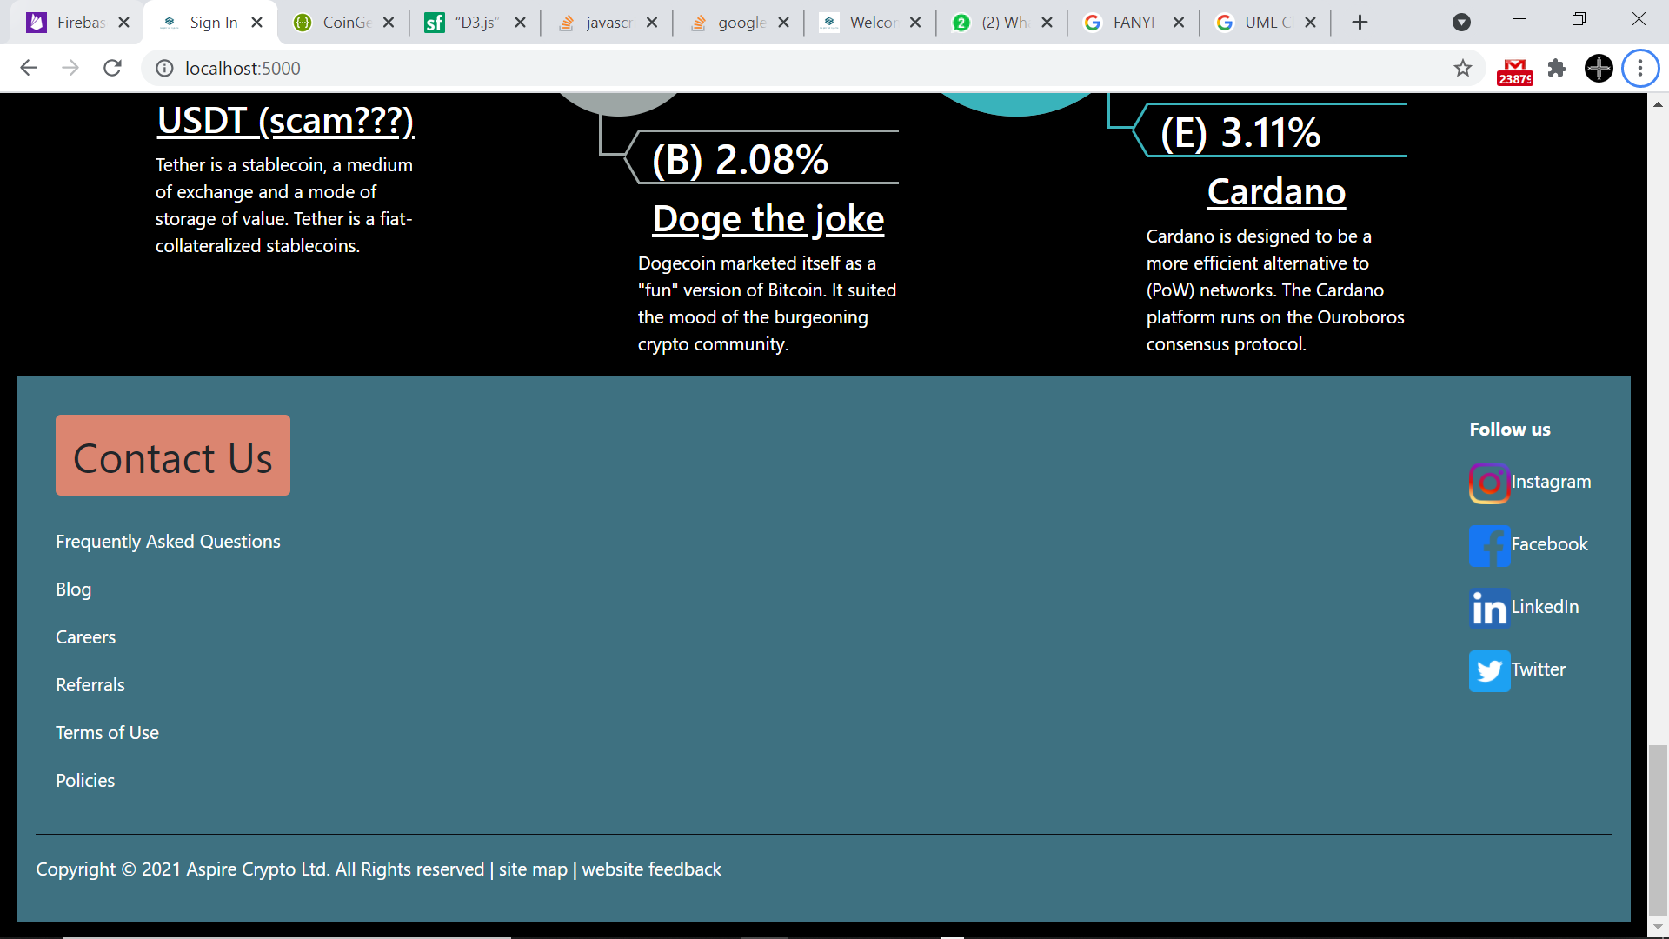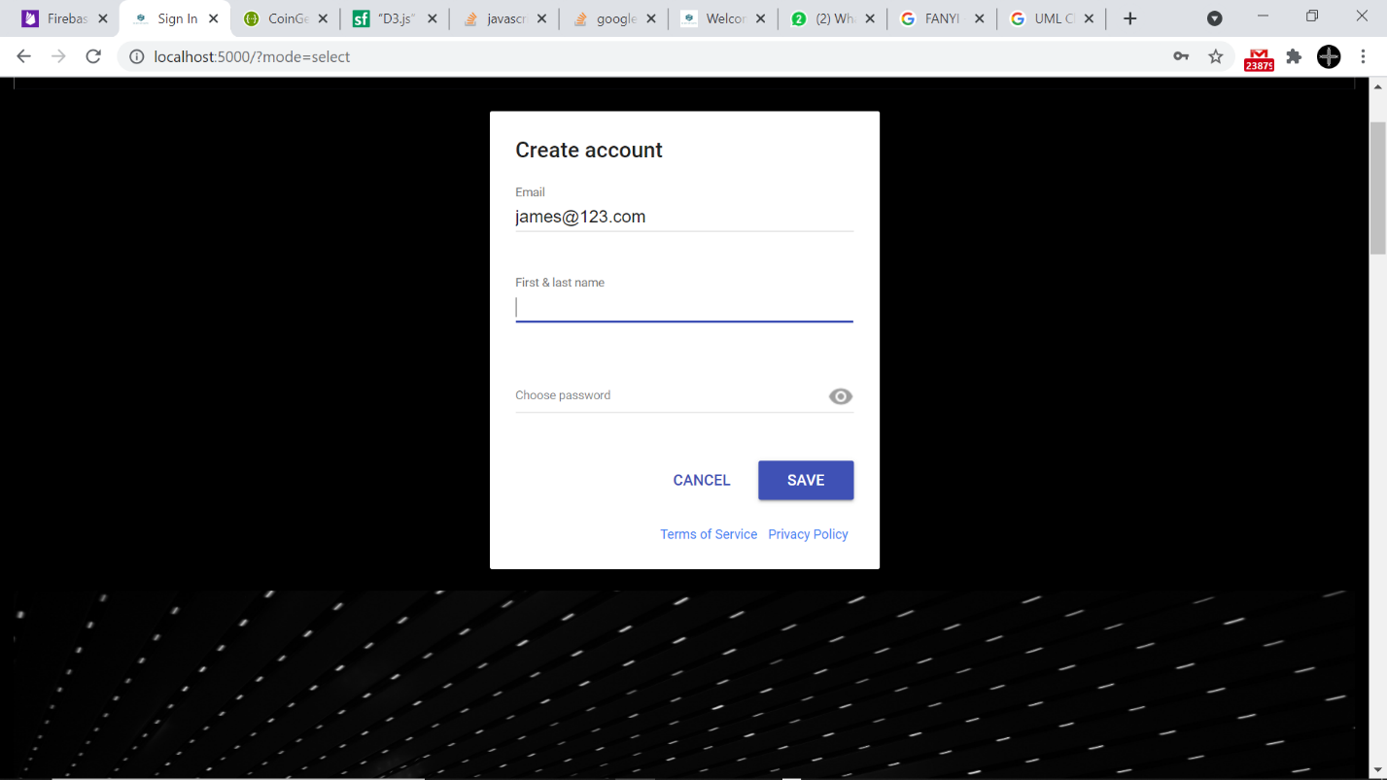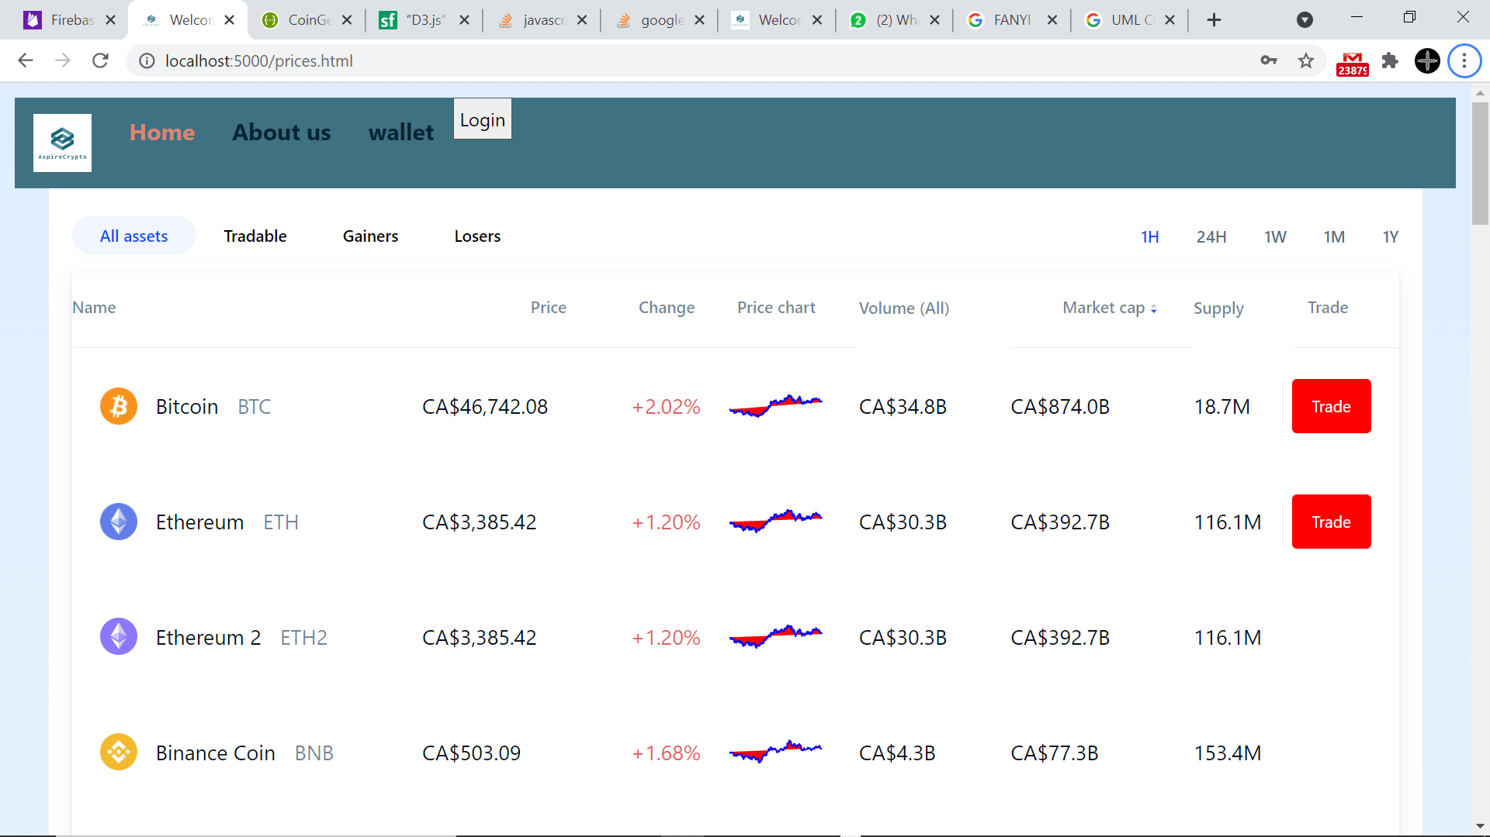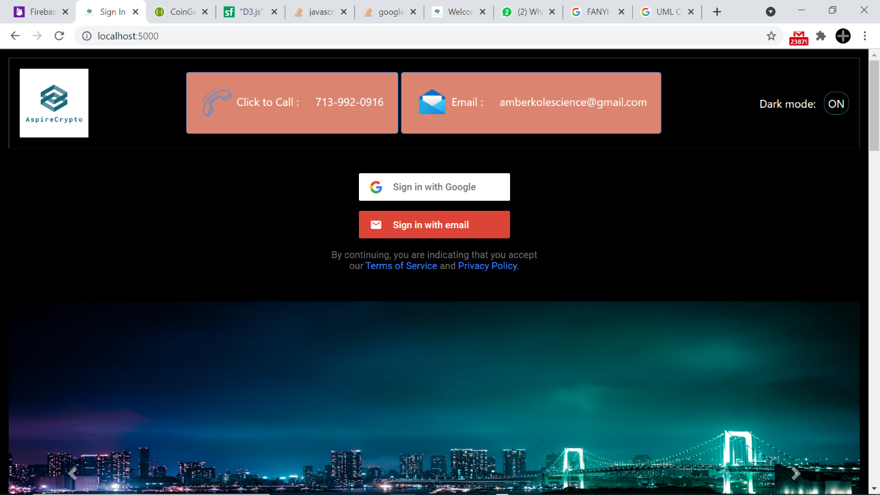

f) the non-functional requirements

1. Efficiency

The market will only contain top 250 coins, to reduce user fatigue in terms of decision making. Otherwise, there will be too much work like loading data. If it is chosen top 10 coins, it will not be enough scope for somebody who willing practice. That’s why 100 coins are a good and optimum number.

1. Usability

The main purpose of usability is to facilitate web site to used by user. Especially, someone who recently trying to learn cryptocurrency should be able to predict how to discover web app properties such as trade coins, buy&sell, display balance of the account and history of the all trade.

1. Performance

APIs will be used to display prices in real time, as well as a limited number of coins will be used. This will increase the performance of the web app. Also limiting the number of web pages as well as displaying data in an easy way without overloading the webpage will drastically improve performance.

g) The revised UML diagrams that reflects tge solution domain.

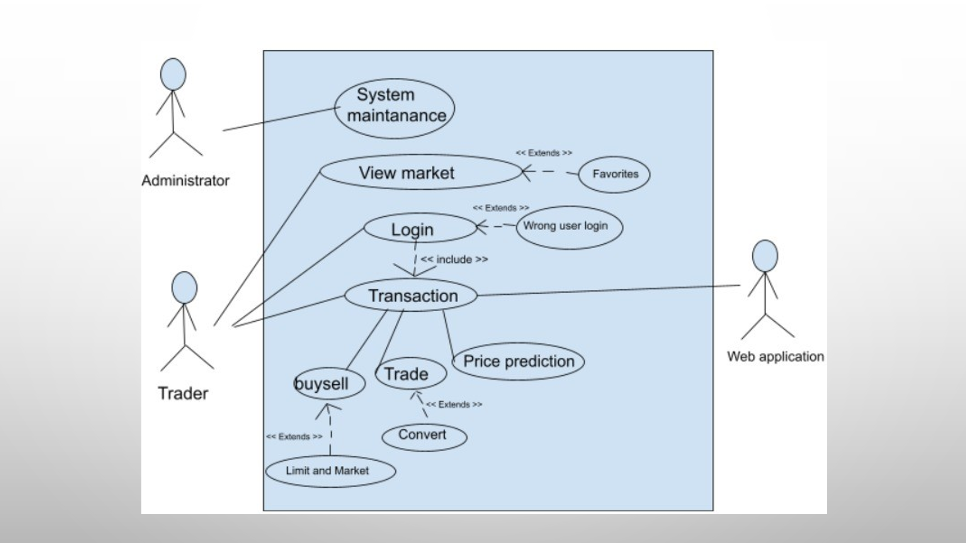

h) Final UML Class Diagrams

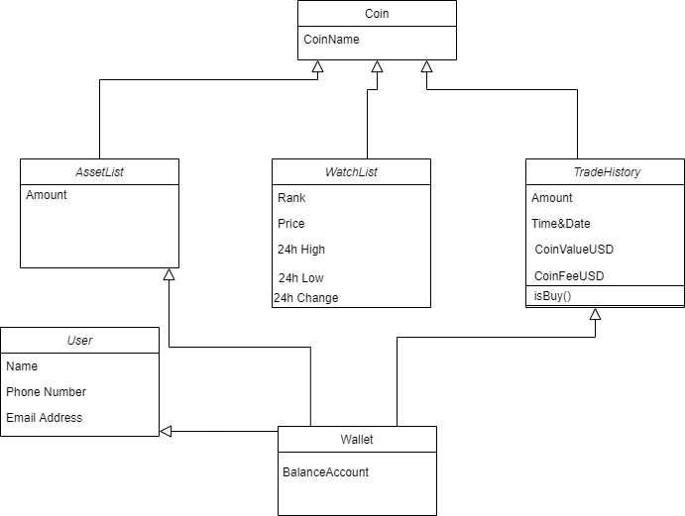

**Overview of System purpose**

The user can login and trade cryptocurrency in a simulate environment this means that they do not need to use their actual money.

This was successfully achieved in our system.

Users can factually monitor the price dynamics of hundreds of cryptocurrencies, and their data is graphed to facilitate user analysis. We introduced AI prediction algorithms, combined with Bitcoin's past market model to give users an intuitive future trend forecast under a certain confidence interval. In this way, the user can intuitively choose to buy or sell the corresponding cryptocurrency on the trading interface.

For system maintenance personnel, to enhance portability, we have introduced an administrator account with higher authority. Administrators can manage the registered user information anytime and anywhere by logging in to the administrator account. They have the right to delete user information. We also made a GUI visual management interface specifically for administrators to make system maintenance convenient.

**NEW Design**



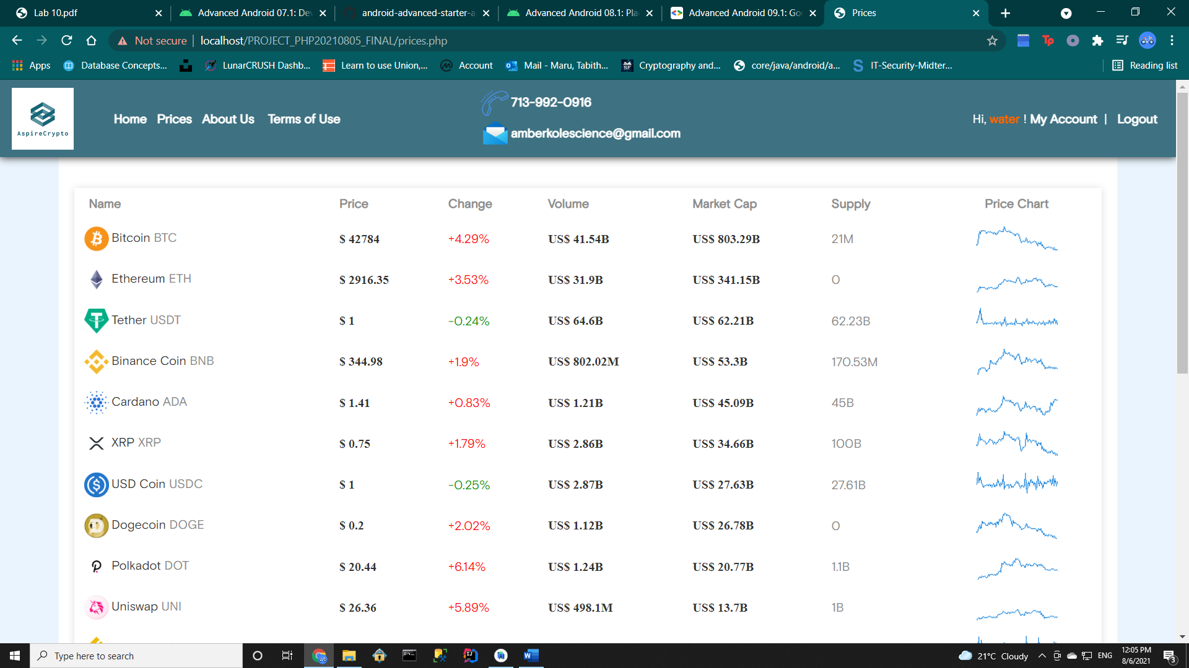

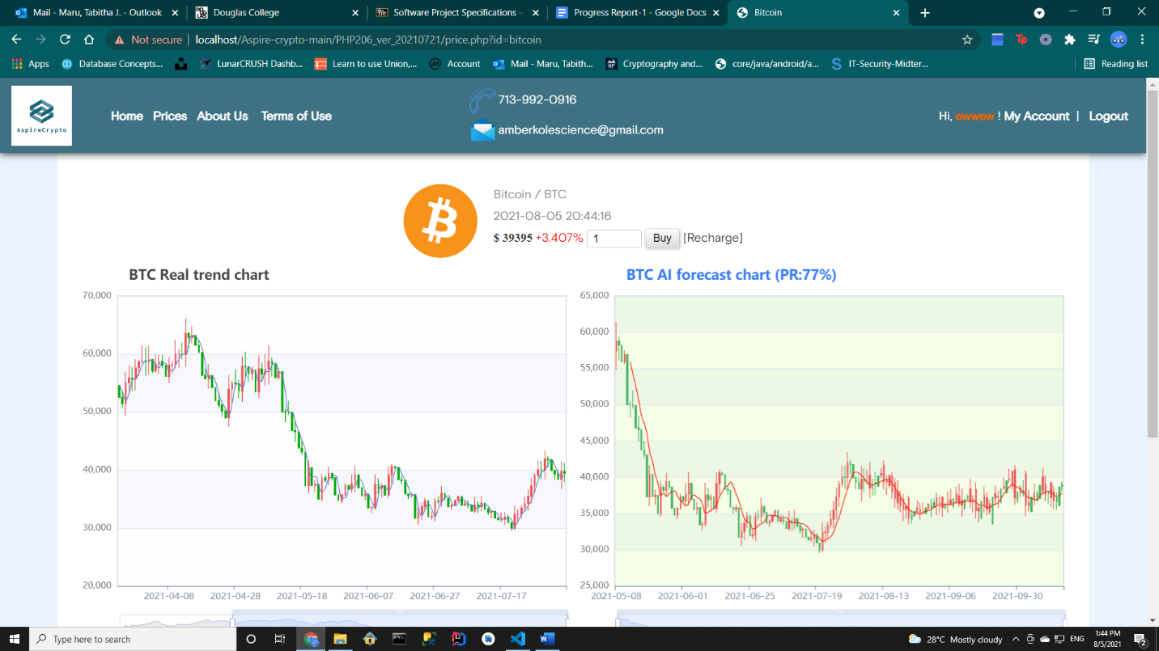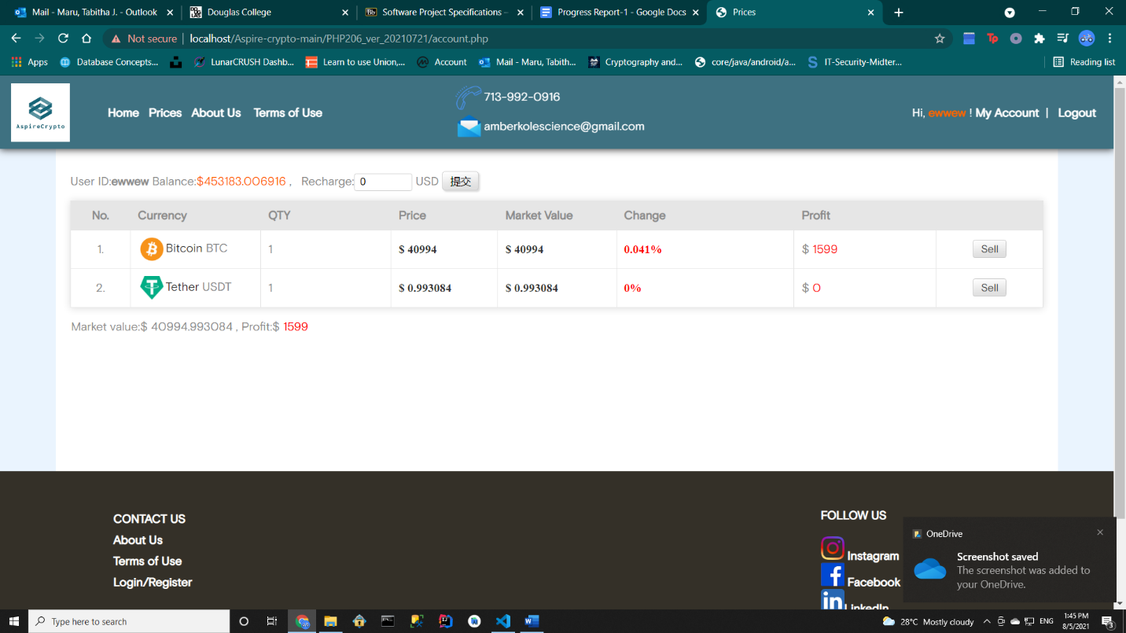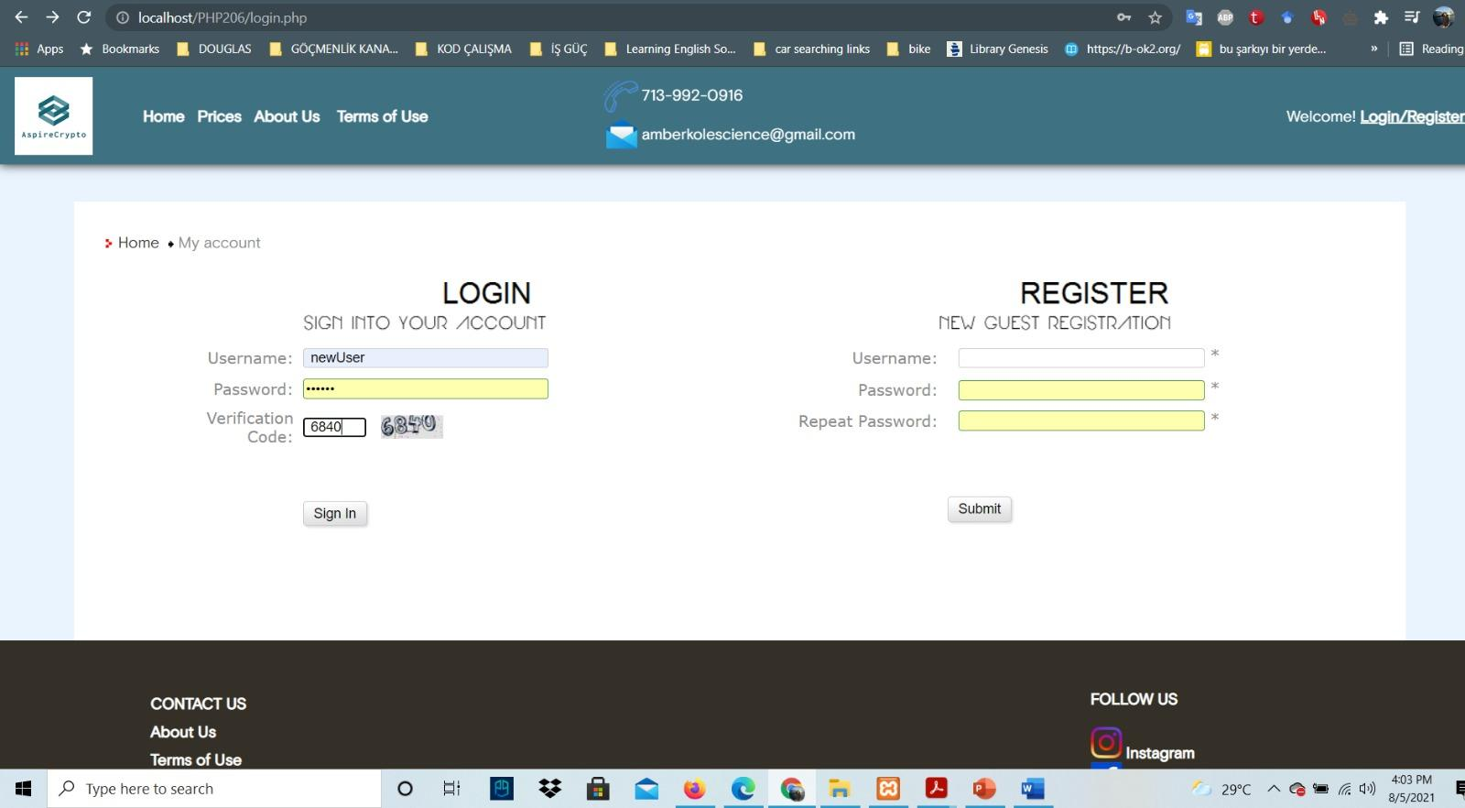

**Implementation**

**Testing:**

We used lighthouse to perform Whitebox testing on our website and the results are in the file.

For security testing we used MD5 password encryption and disguised the database by salting its name. We also trimmed user password length and login name length to prevent any injection attack. The Passwords are all the same after hashed and even the administrators can not see their plain text password.

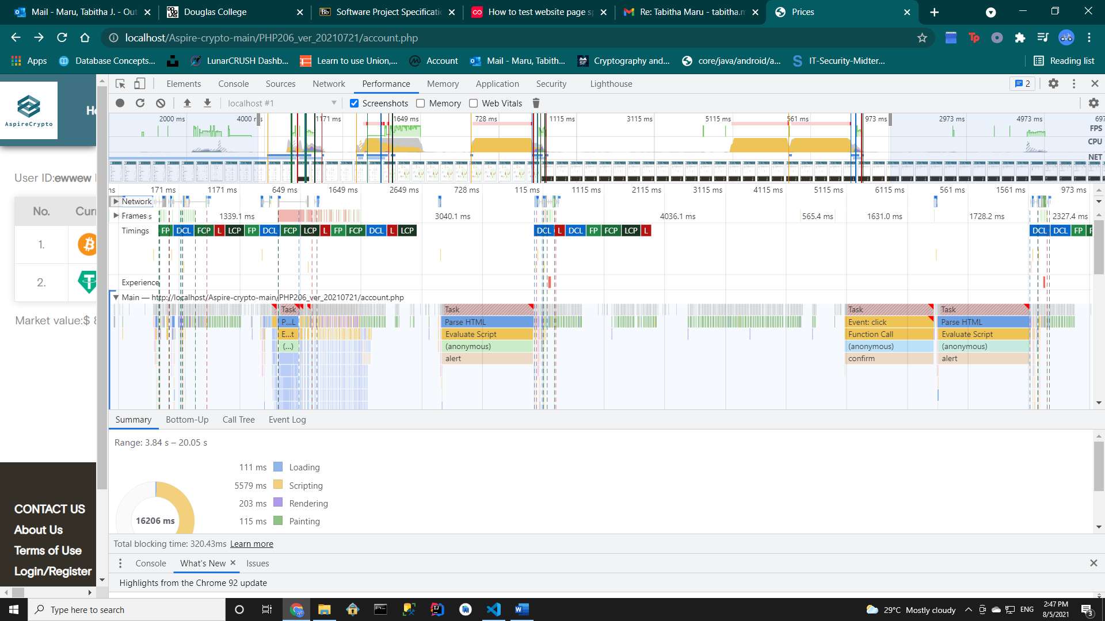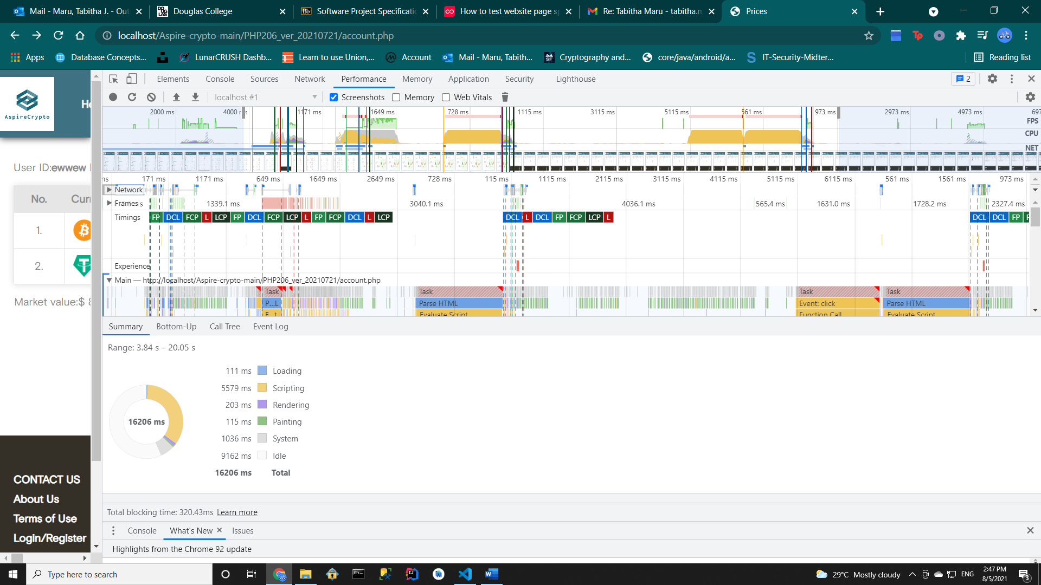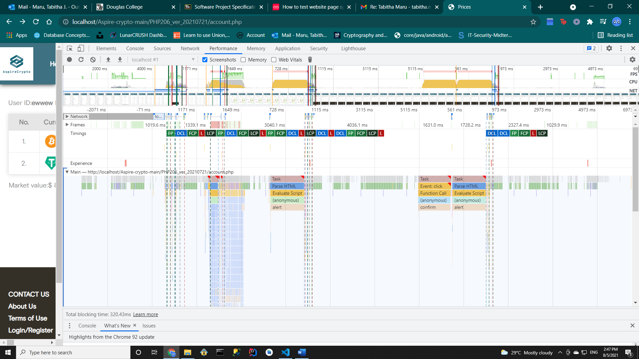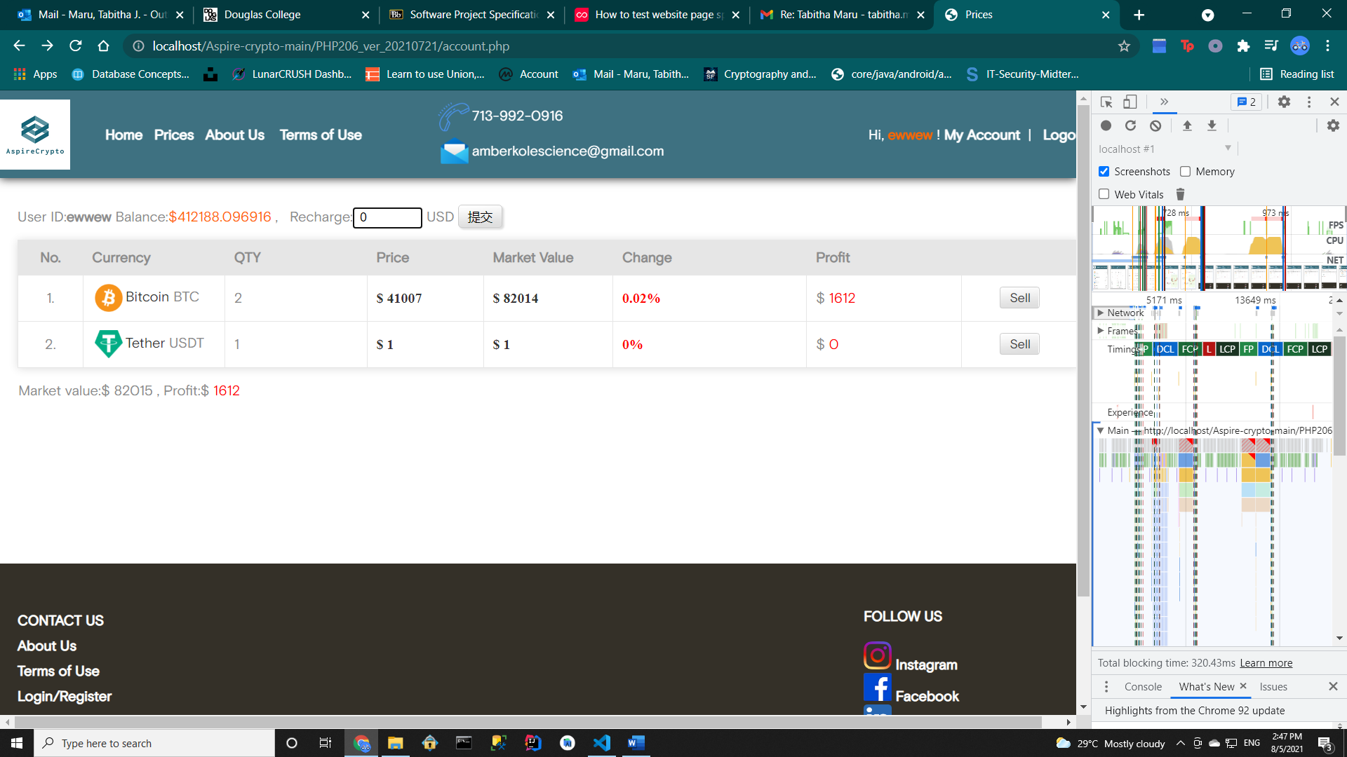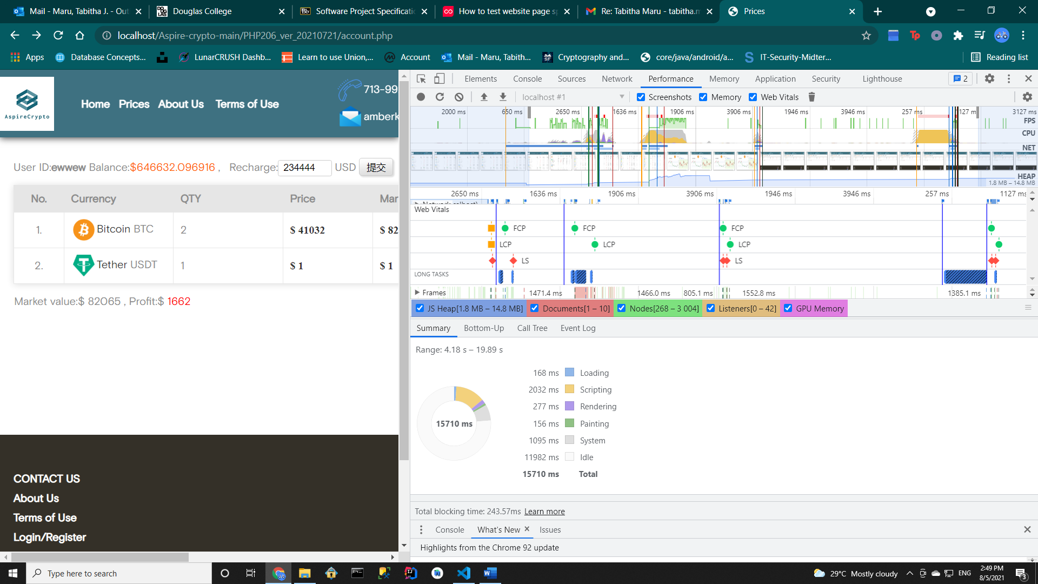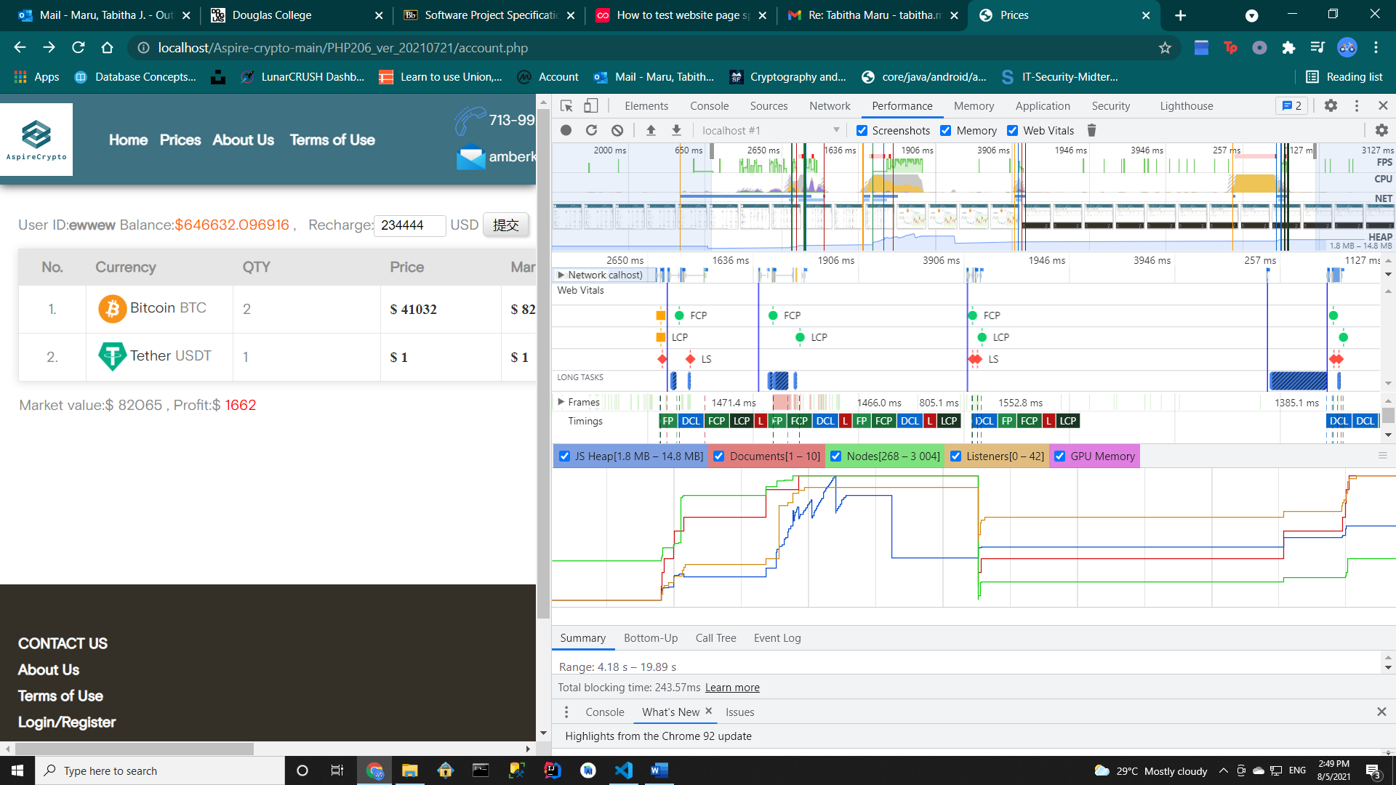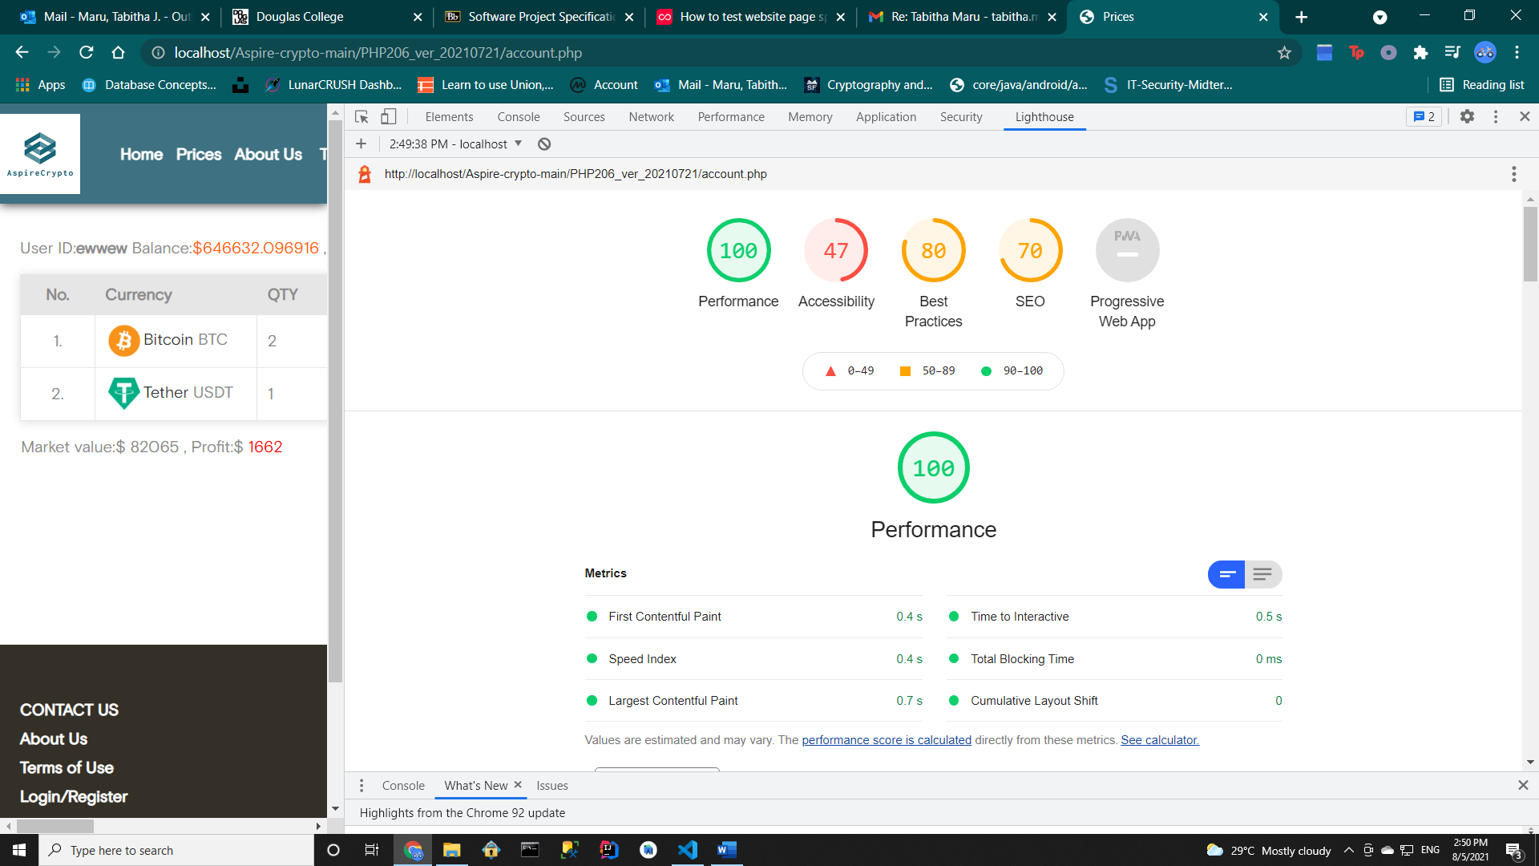

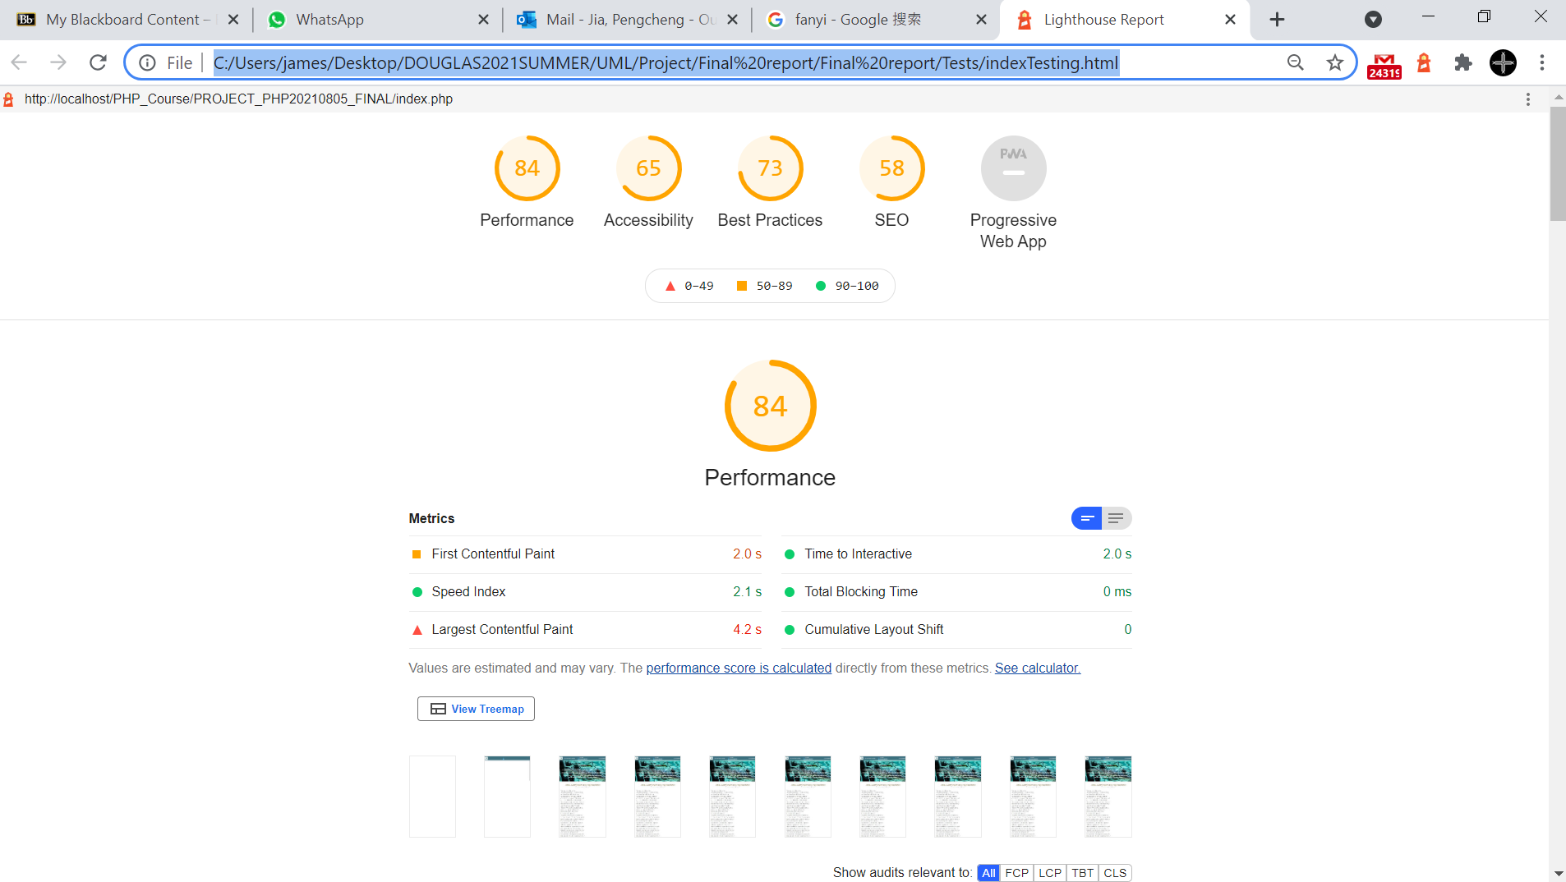

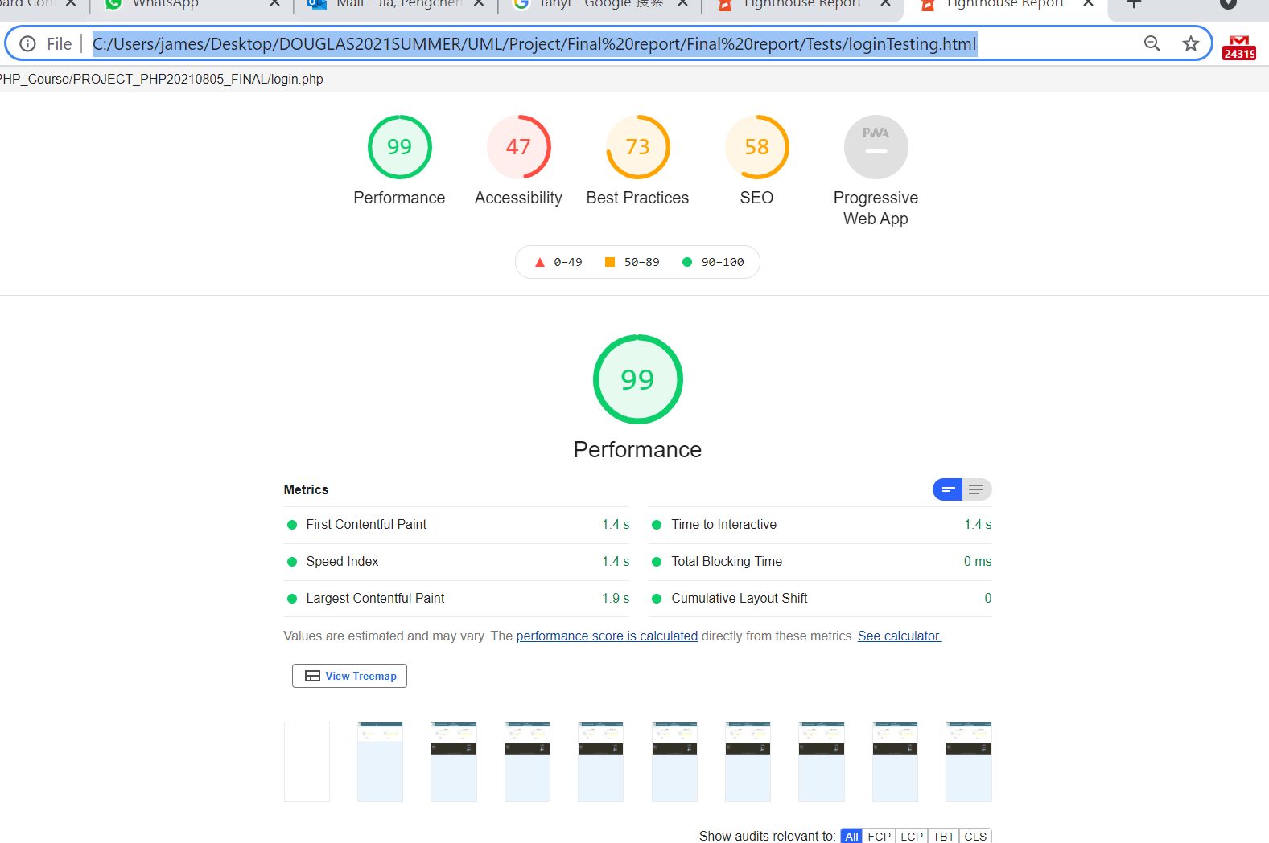

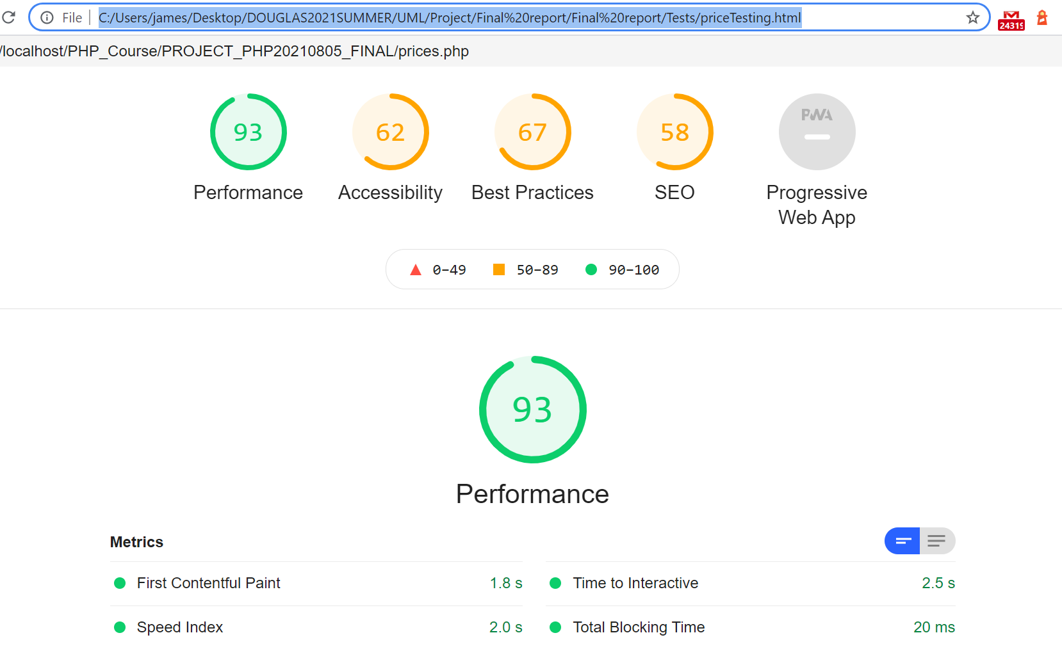



**1. login**

We used SQLite's user table to register new users and log in to existing users. Our administrator user is Admin, and the password is 888888. The administrator account has back-end management permissions, which can view or delete registered users. After the user logs in, the session can be used as the login credentials, and the user clicks to log out and ends the session. When the user logs in, a four-digit verification code image will be randomly generated, which is obscured for man-machine verification. This can prevent DDOS attacks.

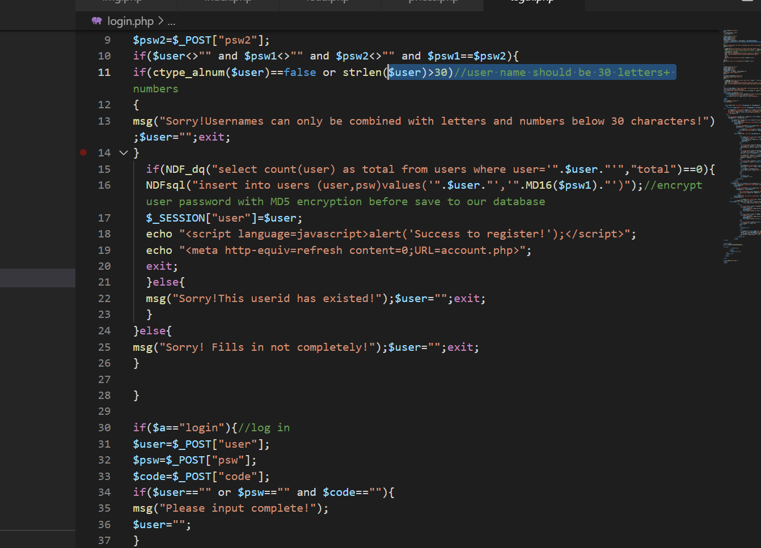

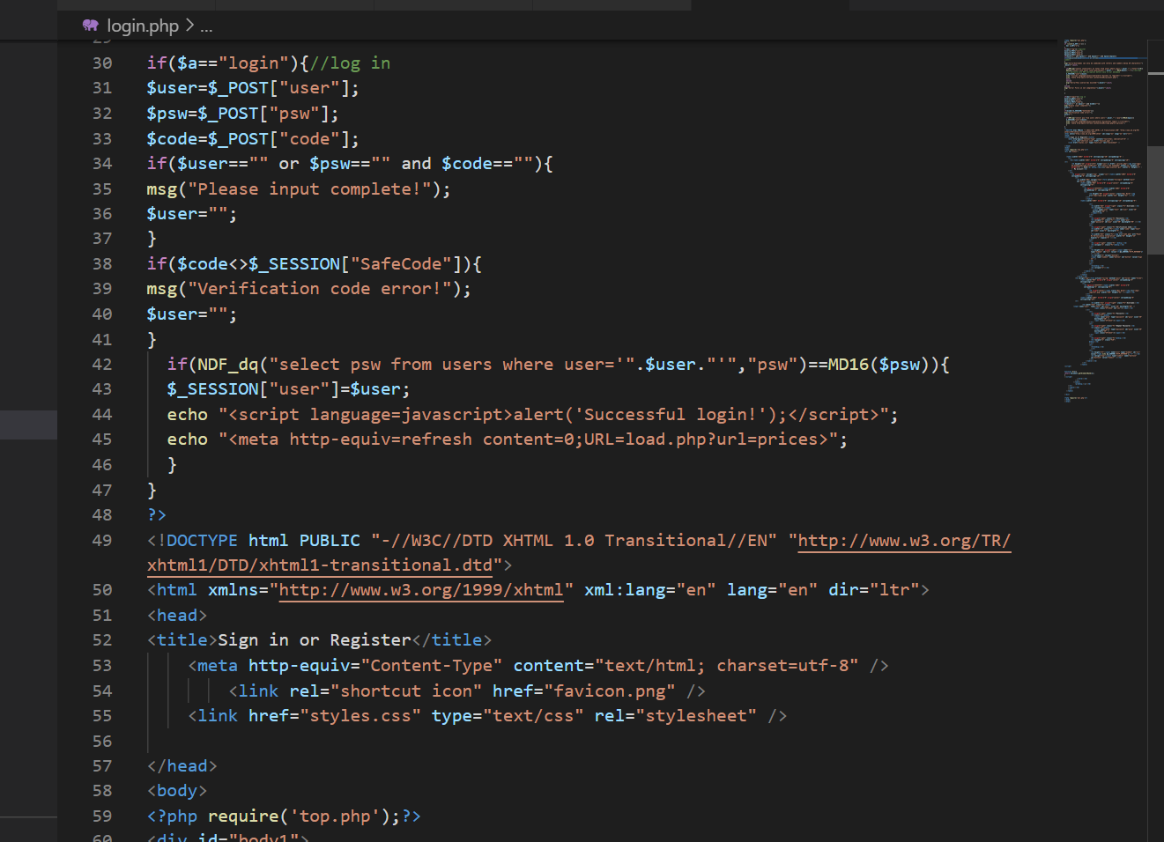

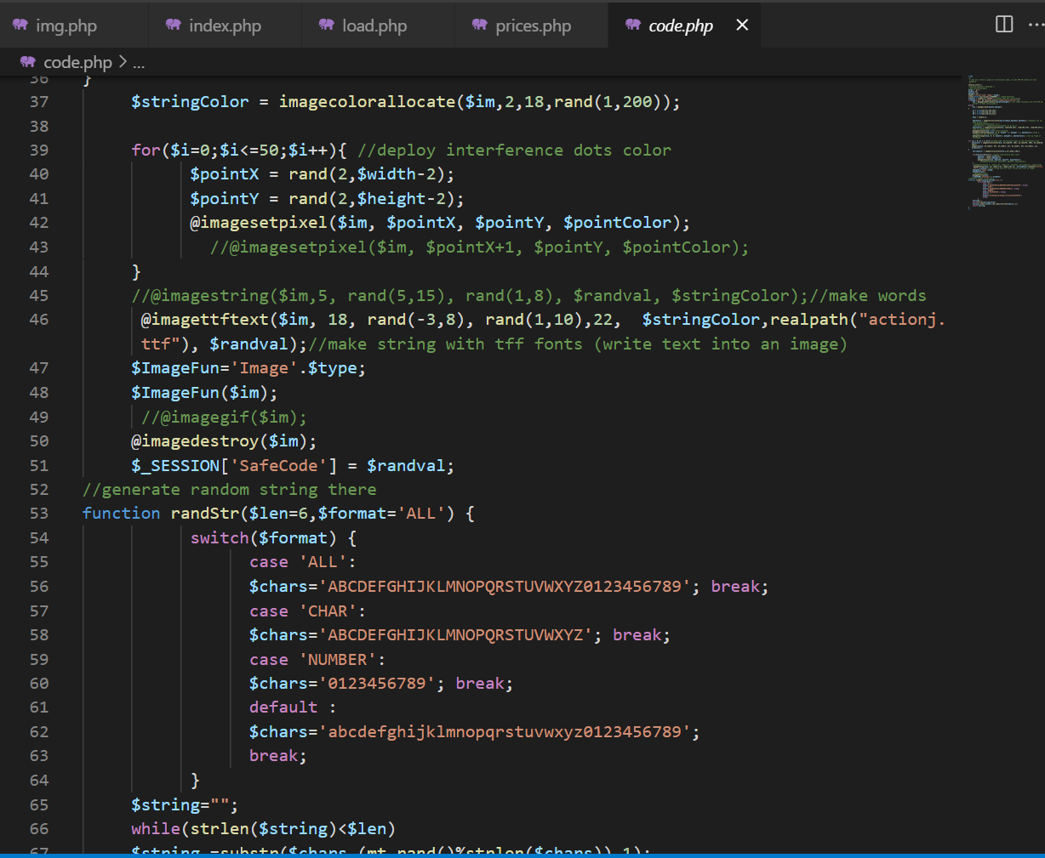



**2. price table display**

We draw a simple line chart of each cryptocurrency by using the isochronous price array obtained from the API (coin gecko). We use php_gd to render the resulting gif pictures and list the market quotations of each cryptocurrency. API price data is refreshed through AJAX every 30 seconds automatically. This means there is no need to reload the web page manually to renew the prices.

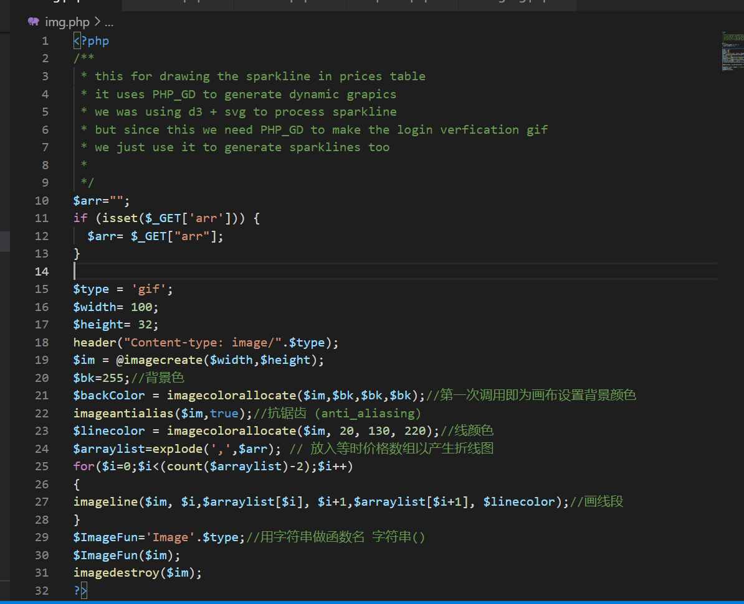

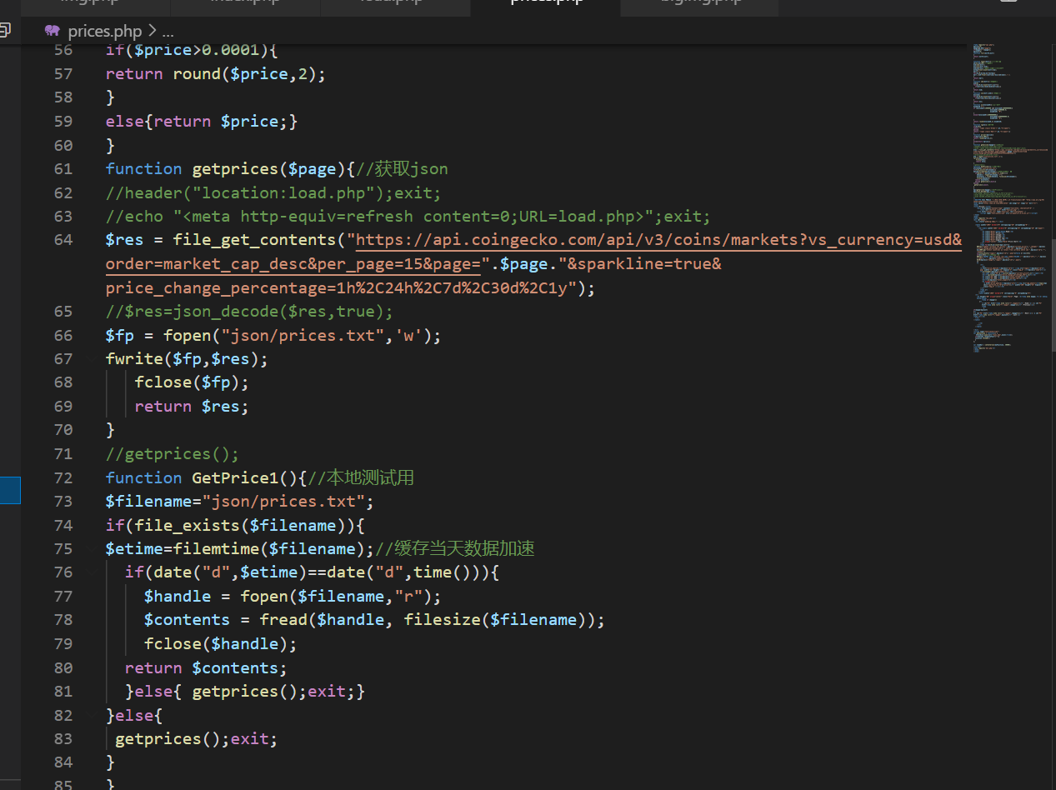

**3.Price prediction and Sparkline graphing**

According to the Bitcoin production reduction model, we found the fitting interval of its K-line, and from the moving average we can give the confidence interval for the prediction of future prices. If the Bitcoin K-line is closer to the extreme value of the model interval, the lower the confidence of the prediction. On the contrary, if the obtained K-line is close to the mean value of the prediction, the confidence of this prediction is high.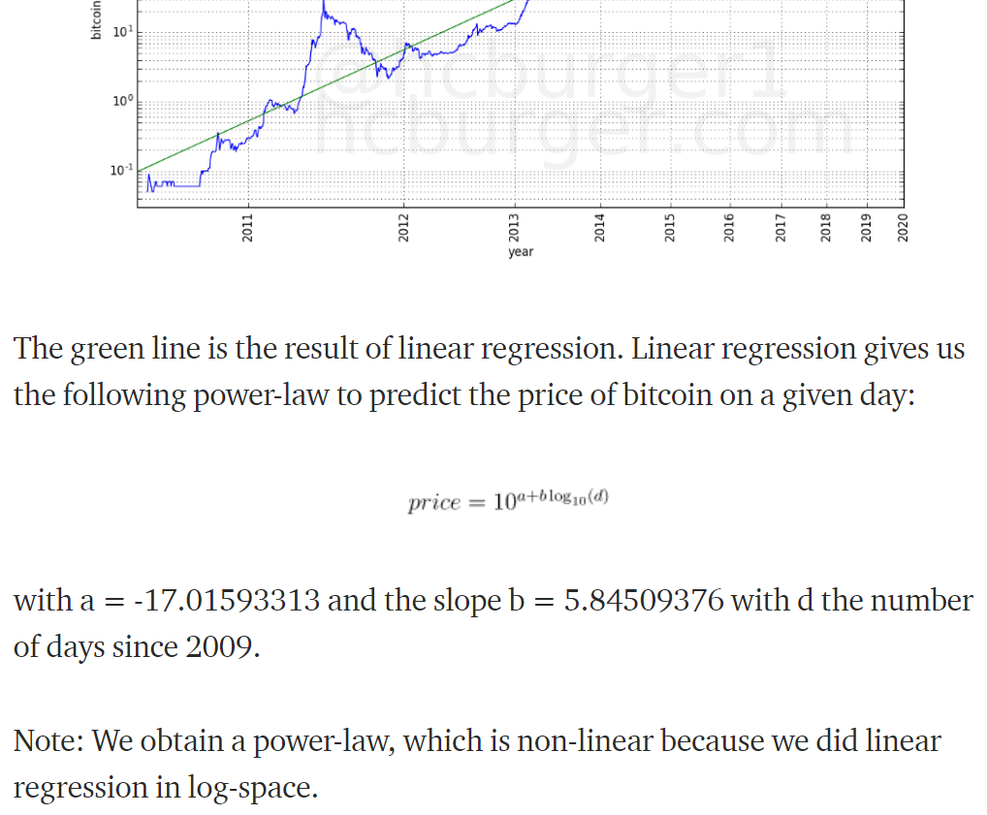

According to the Bitcoin market cycle, we have observed similarities between each Bitcoin market. In general, the market brought about by the reduction of bitcoin production creates an extreme value within 4 years. The extreme value of the bull market conforms to the regression formula described above, so we only need to take the average value of the current market based on the K-line of the previous market. And then smoothing can predict the next trend of Bitcoin within a certain confidence interval.

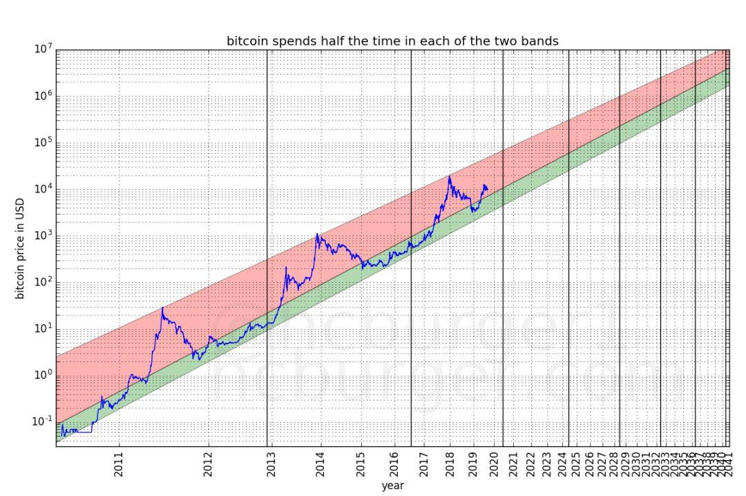

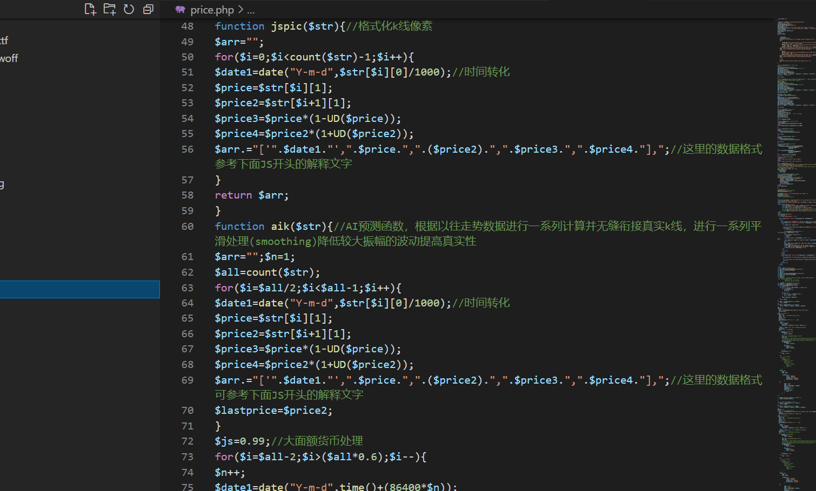

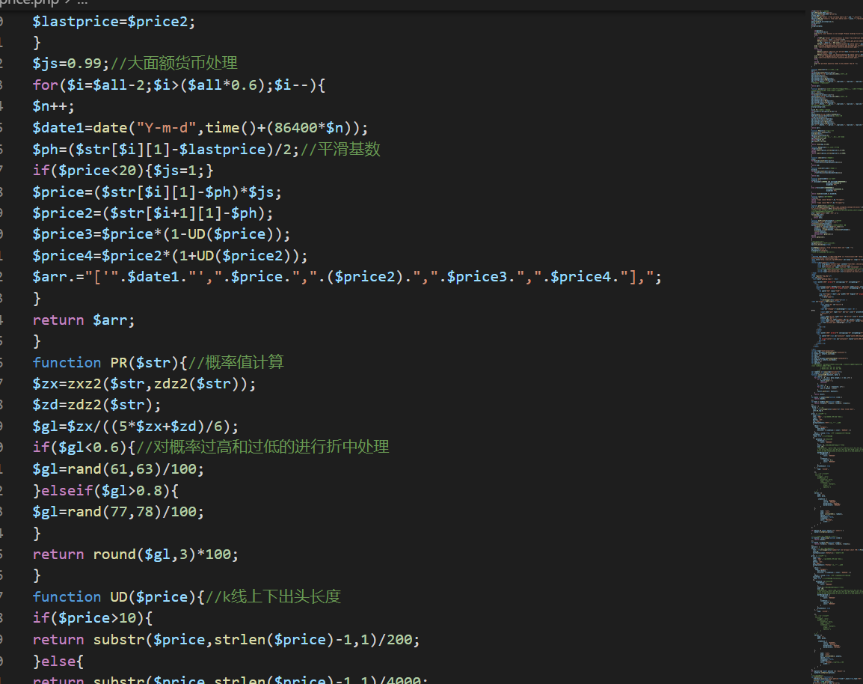

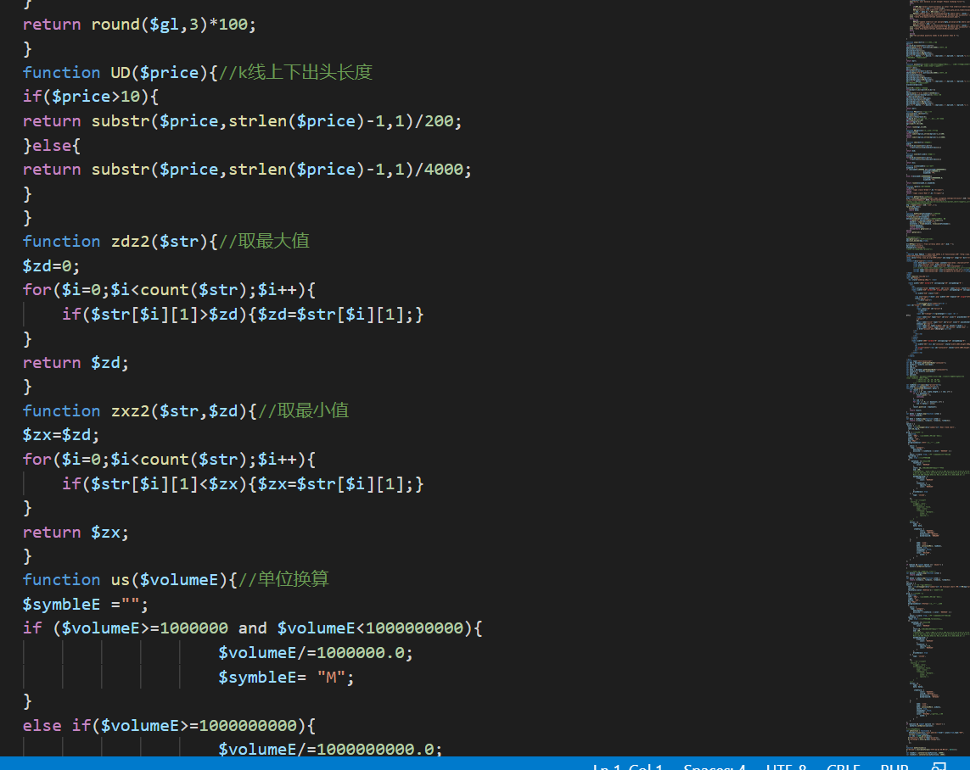

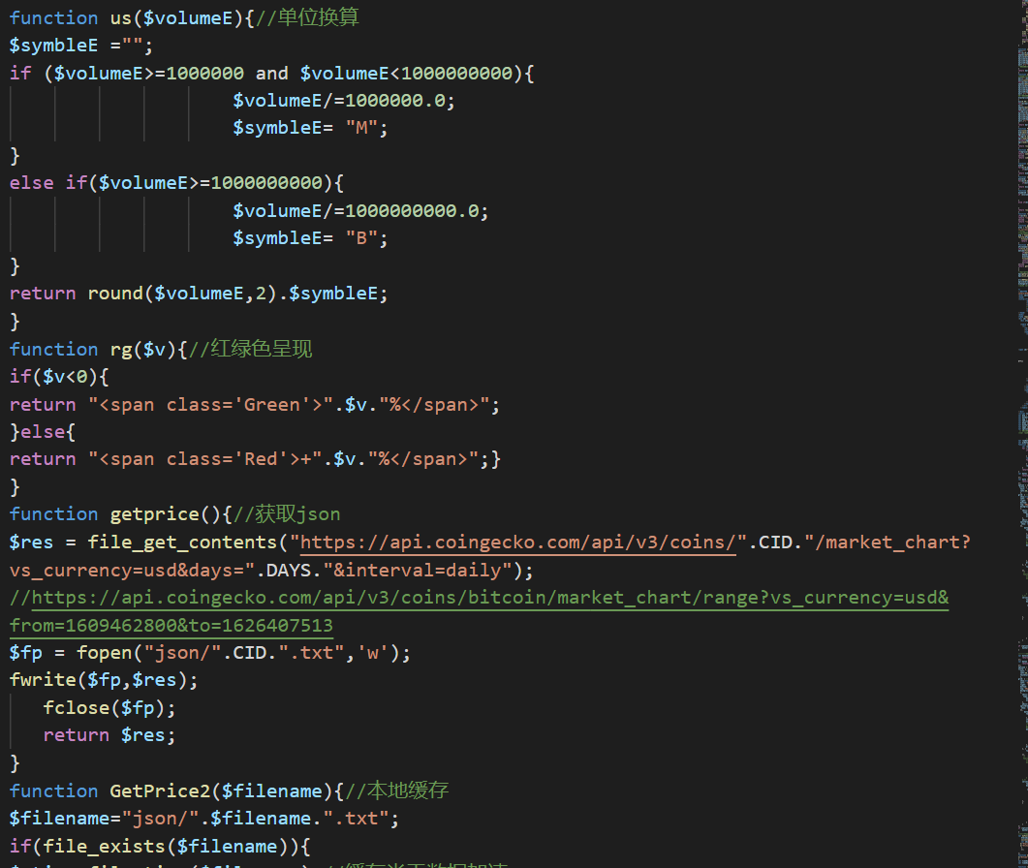

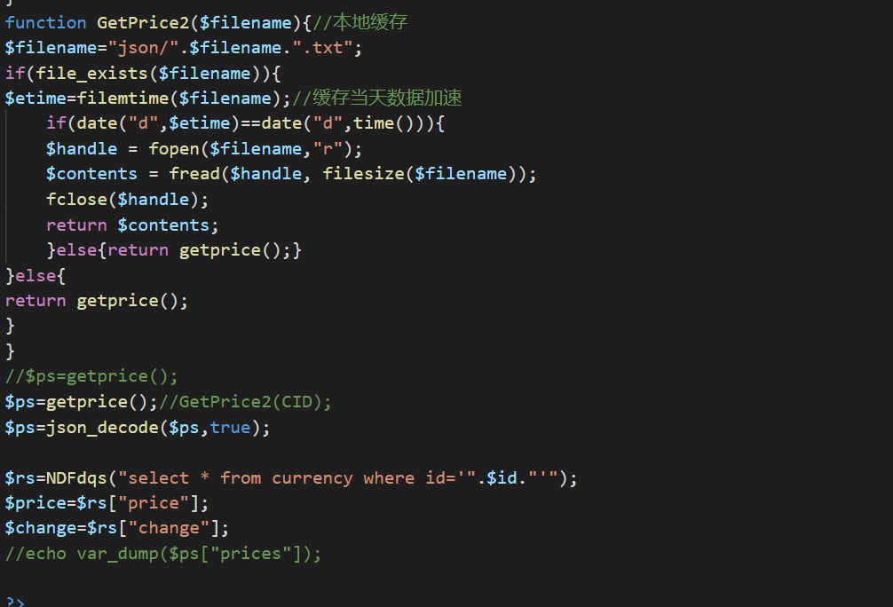

**4 manage user trade**

The database file executes the user's buying and selling, and save these transaction records statically in the SQ##l.db file. We add "#" to the database name to prevent attackers from retrieving the back-end SQL database. The attacker may retrieve some keywords to steal files. We update the order table and user table corresponding to each transaction. If the user buys, we deduct the corresponding amount from the balance of the user table and add the amount of currency purchased and the currency ID in the order table. This applies, if the user sells.

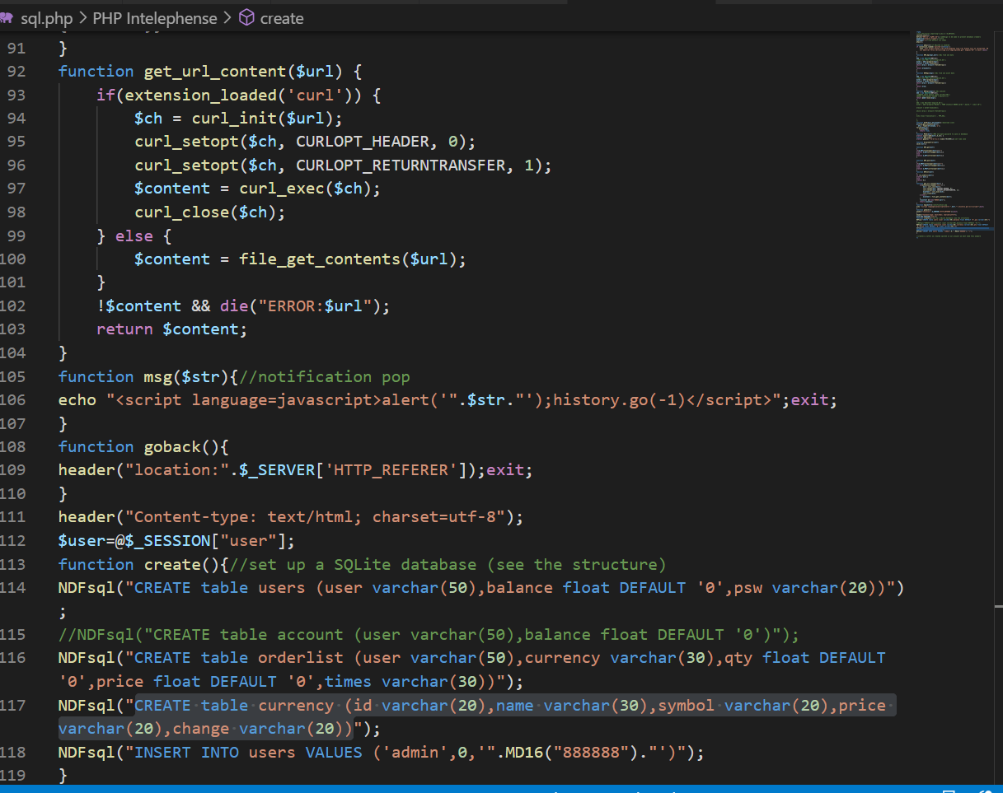

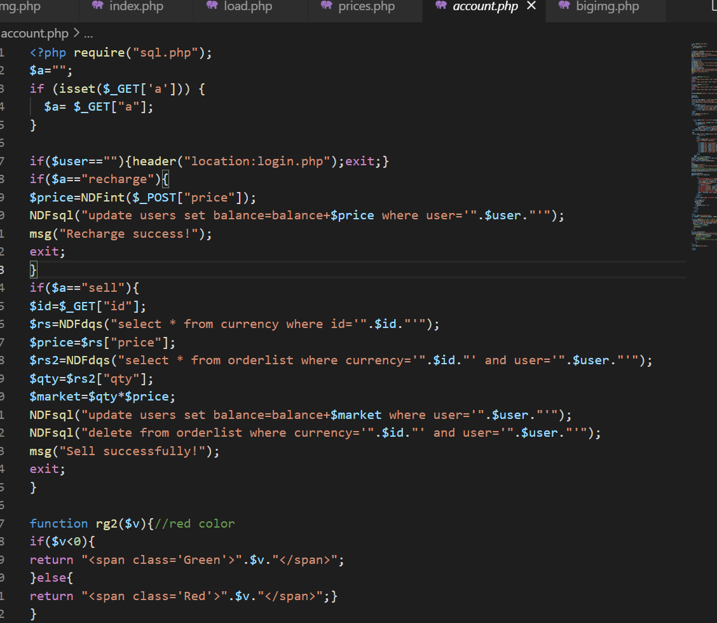

**5.API using**

AJAX is used to dynamically obtain the JSON data information of all the currencies we need from Coin gecko, and we store this information in the price.txt of the backend as data. Then we update these price data to SQLite3 in real time.

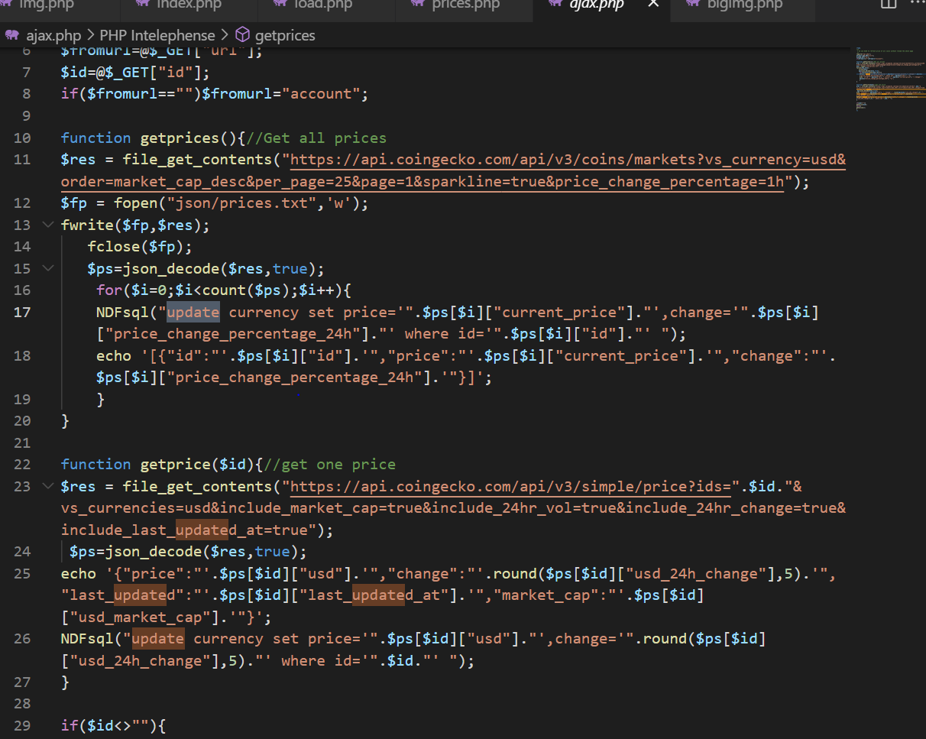

We also ensure the portability and stability of the program through many user black box tests and repairs

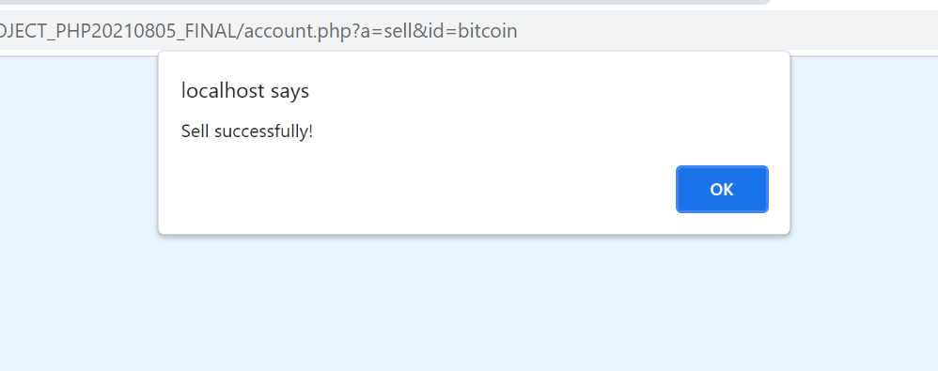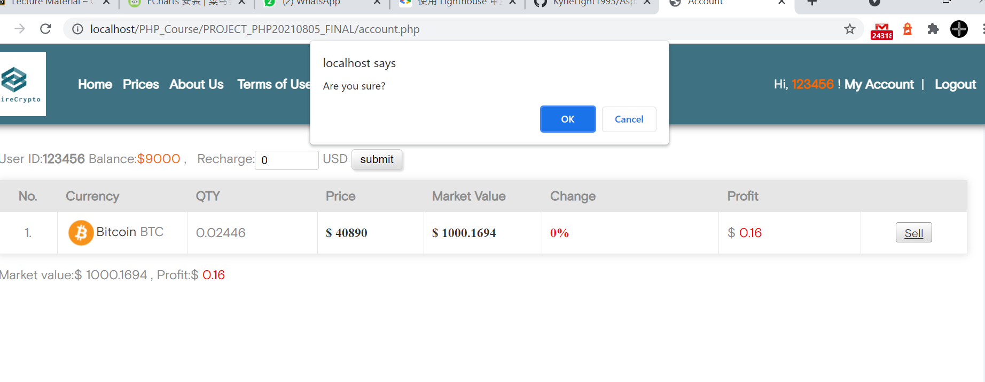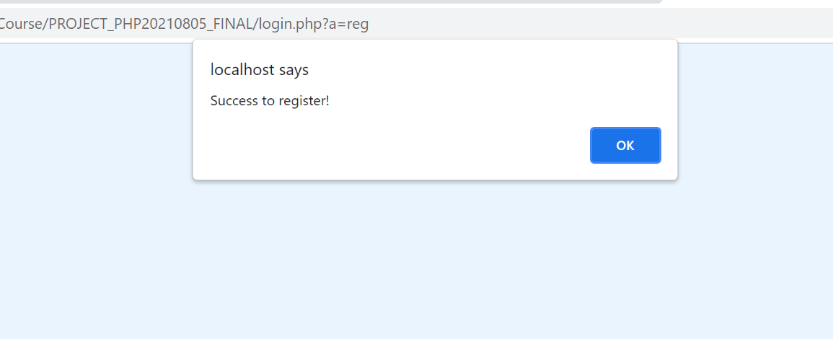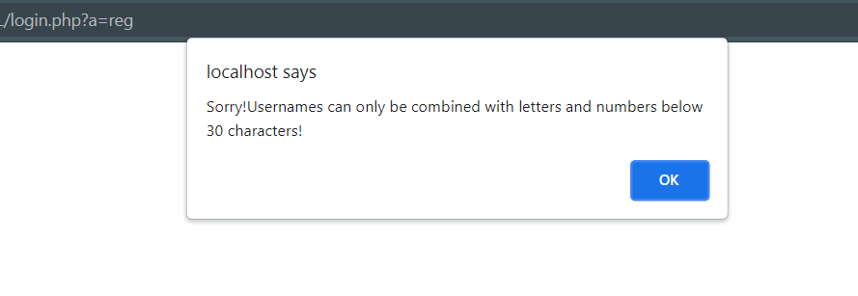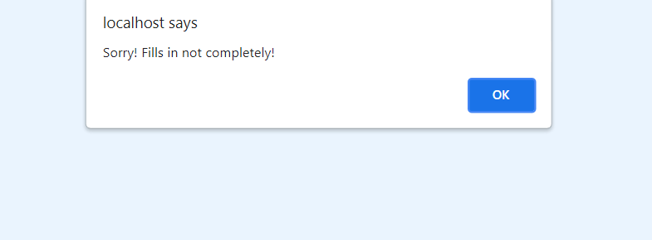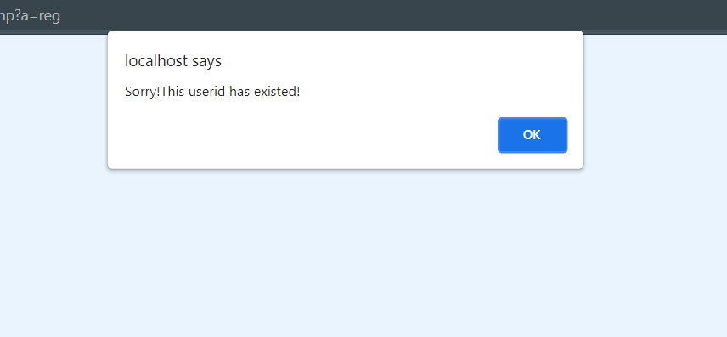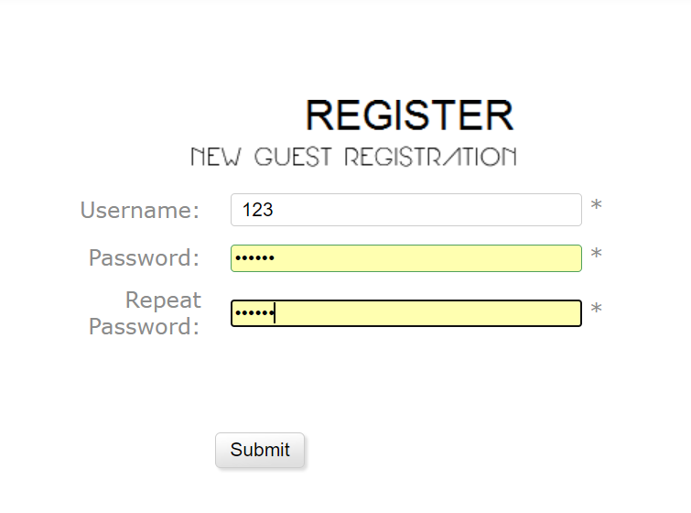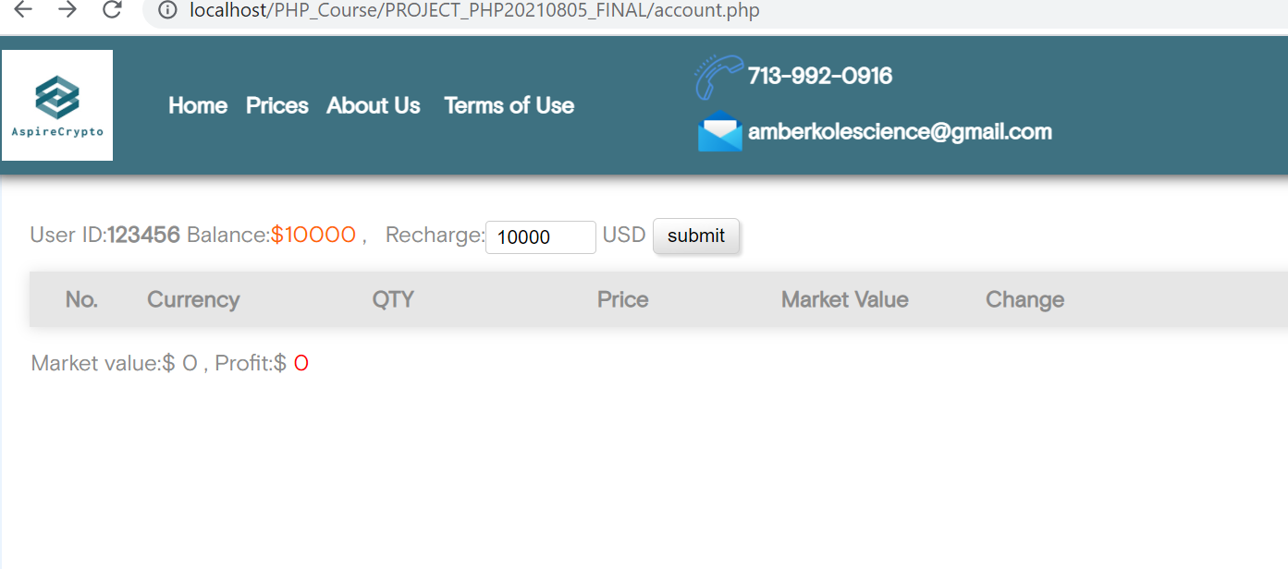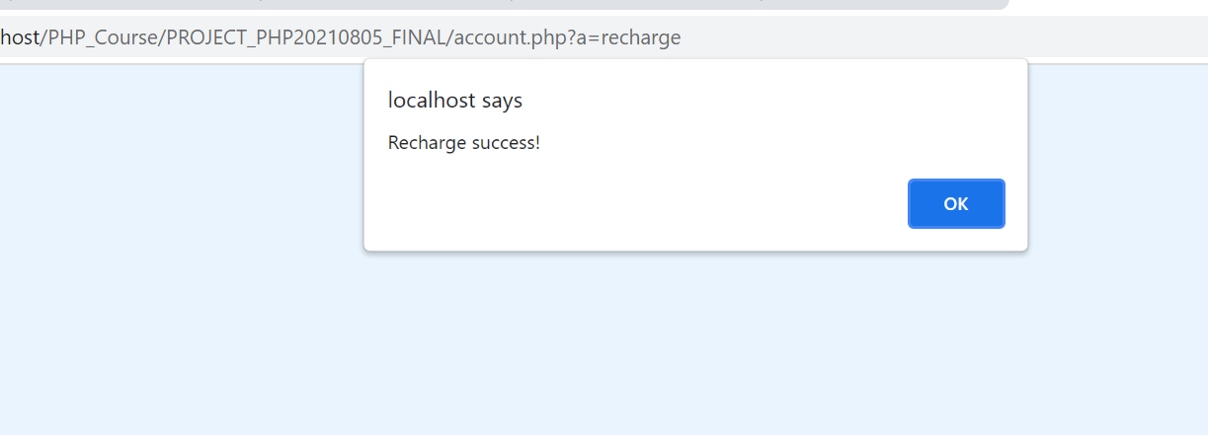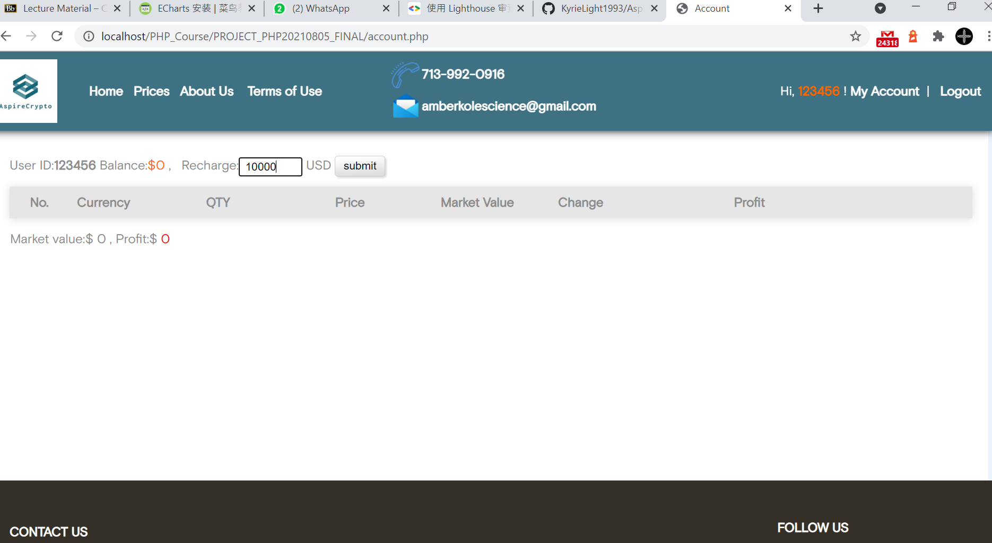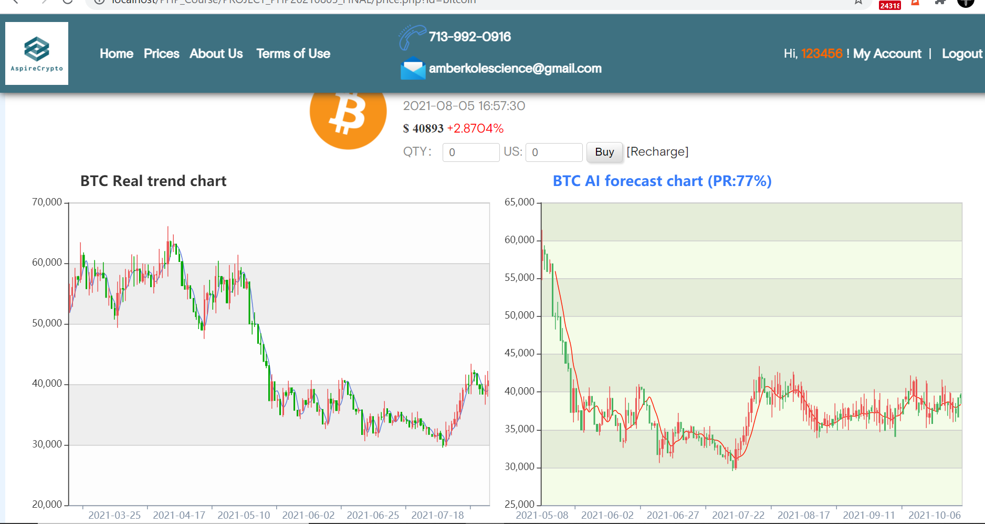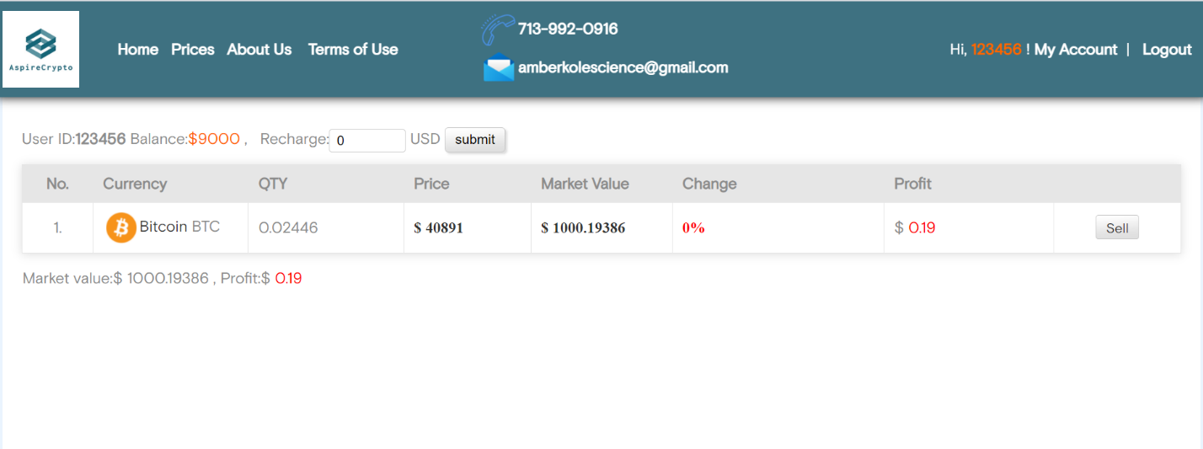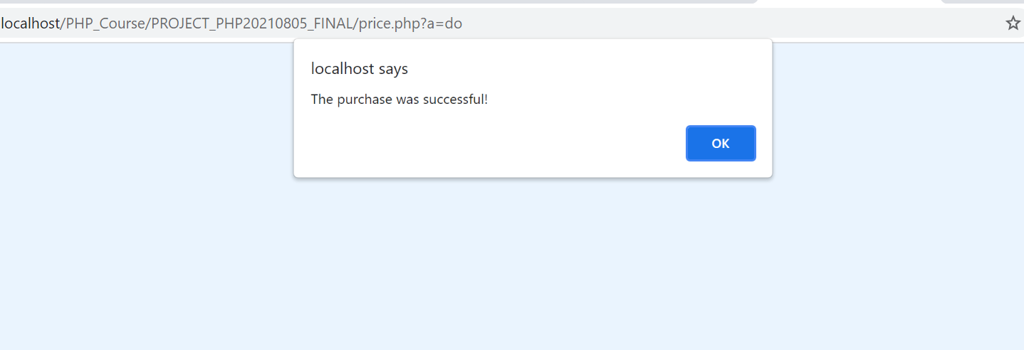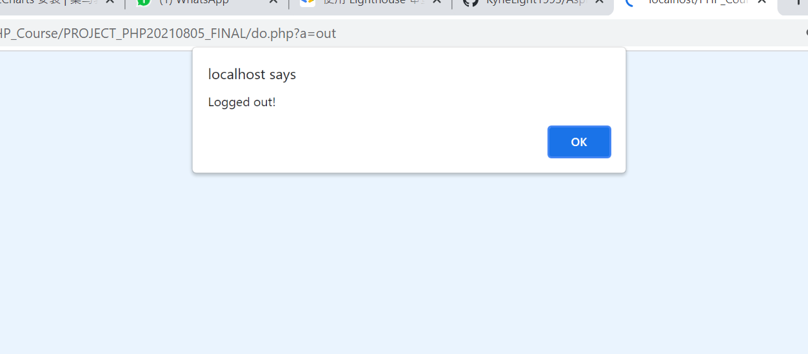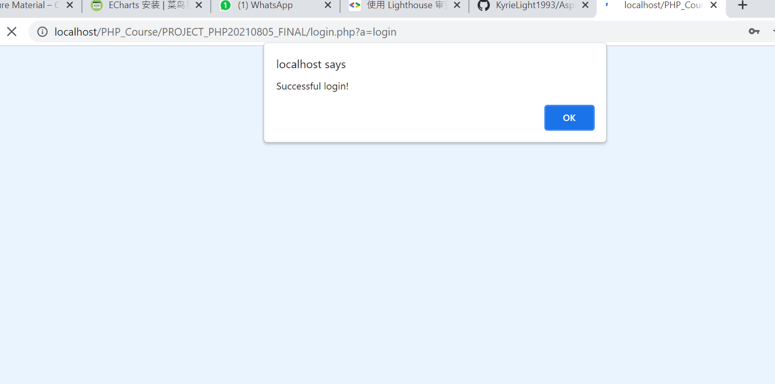 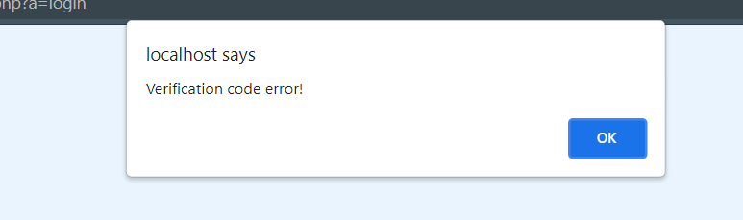 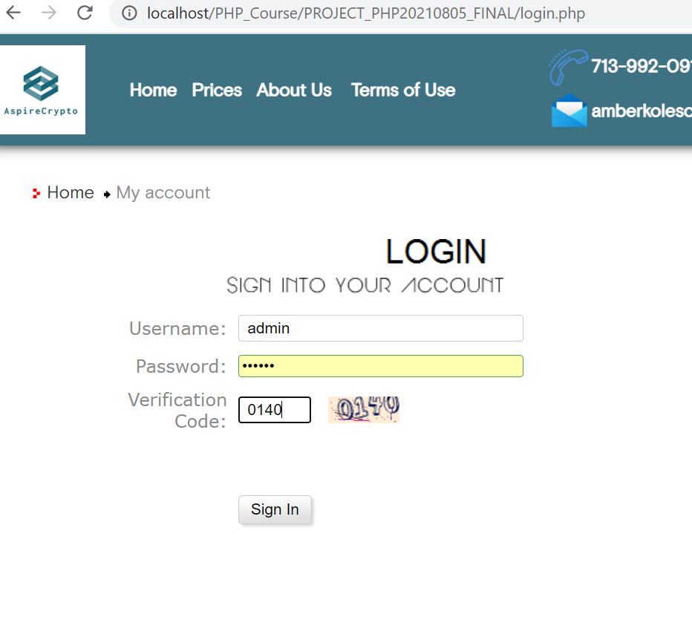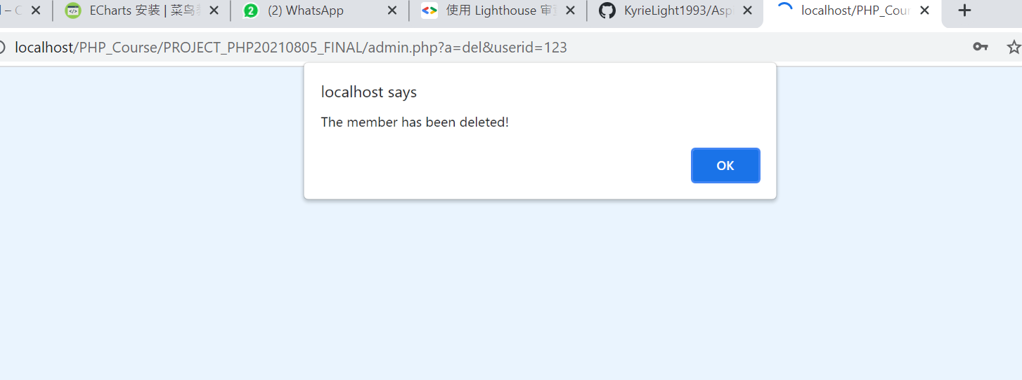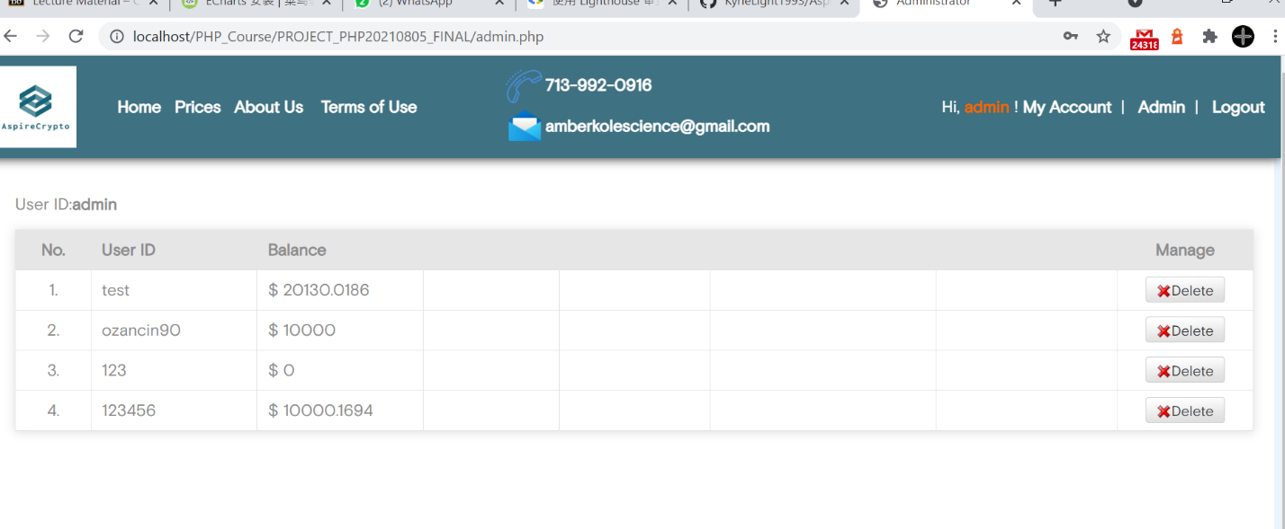

Please see our project via this link

https://drive.google.com/drive/folders/1v18QNcz0uWhFoT4jepwut_Z9jSOha9Eq?usp=sharing